
University of Science and Technology of Southern Philippines

Alubijid | Balubal | Cagayan de Oro | Claveria | Jasaan | Oroquieta | Panaon | Villanueva

ThesisTrack: Development of a Thesis and Capstone Project Inventory, Progress Monitoring, and Technology Transfer Management System for Higher Education Institutions

Achas, Princess Mae Camille N.
Bitos, Ivy A.
Graniten, Kyle Japheth C.
Juntilla, James Anthony Z.

A Capstone Project

Department of Information Technology
University of Science and Technology of Southern Philippines – Jasaan Campus
Jasaan Misamis Oriental, 9003, Philippines

June 2026
CERTIFICATE OF ORIGINALITY

This is to certify that the research work entitled “ThesisTrack: Development of a Thesis and Capstone Project Inventory, Progress Monitoring, and Technology Transfer Management System for Higher Education Institutions” is an original work carried out by Princess Camille N. Achas, Ivy A. Bitos, Kyle Japeth C. Graniten, and James Anthony Z. Juntilla in partial fulfillment of the requirements for the degree of Bachelor of Science in Information Technology at the University of Science and Technology of Southern Philippines – Jasaan Campus.
We hereby declare that this research is entirely our own work and has not been copied from any other source, except where proper acknowledgment and citation have been made. This study has not been submitted, either in whole or in part, to any other institution for academic credit. All sources of information, including ideas, data, and quotations from other authors, have been properly cited and referenced in accordance with academic standards. We fully understand that any form of plagiarism or academic dishonesty will result in disciplinary action in accordance with the policies of the university.

This certificate is issued to affirm the authenticity and originality of the research work.

Approved by:
JIMVY P. SALISE, MIT
Capstone Adviser/Head, Information Technology Department
USTP Jasaan
TABLE OF CONTENTS
 | PAGE
TITLE PAGE | i
CERTIFICATE OF ORIGINALITY | ii
TABLE OF CONTENTS | iii
CHAPTER I: INTRODUCTION | 6
1.1 Background of the Study | 6
1.2 Conceptual Framework | 7
1.3 Statement of the Problem | 9
1.4 Objectives of the Study | 10
1.5 Significance of the Study | 11
1.6 Scope and Limitation of the Study | 12
1.6.1 Scope of the Study | 12
1.6.2 Limitation of the Study | 13
1.7 Definition of Terms | 14
CHAPTER II: REVIEW OF RELATED LITERATURE | 17
2.1 Research Repository and Inventory Systems | 17
2.2 Monitoring and Evaluation in Academic Systems | 20
2.3 Innovation, Technology Transfer, and Research Advancement Systems | 22
CHAPTER III: RESEARCH DESIGN AND METHODOLOGY | 28
3.1 Research Design | 28
3.2 Research Environment | 51
3.3 Unit of Analysis, Respondents, and Sampling | 53
3.3.1 Sampling Technique | 53
3.4 Data Gathering Instruments and Procedure | 54
3.5 Statistical Instruments Procedure | 56
REFERENCES | 58
APPENDICES | 61
LIST OF FIGURES
- Figure 1 - Input-Process-Output Diagram
- Figure 2 - RAD Model for System Design
- Figure 3 - System Architecture of ThesisTrack
- Figure 4 - User Interaction and External Service Context
- Figure 5 - Integrated Data Flow and Process Interaction
- Figure 6 - Student Research Project Workflow and Progress
- Figure 7 - Adviser and Panel Evaluation Workflow
- Figure 8 - Department Chair Monitoring and Research Oversight Workflow
- Figure 9 - Research Head Institutional Monitoring and Technology Transfer Workflow
- Figure 10 - Library Repository Validation and Archiving Workflow
- Figure 11 - Industry Partner Collaboration and Technology Transfer Workflow
- Figure 12 - System Administration and Platform Management Workflow
- Figure 13 - Object Modeling of ThesisTrack
- Figure 14 - Functional Interaction of Users and Core Features in the ThesisTrack System
- Figure 15 - Authentication and Project Registration Sequence
- Figure 16 - Manuscript Submission and Faculty Evaluation Sequence Workflow
- Figure 17 - Defense Evaluation, Repository Validation, and Archiving Sequence Workflow
- Figure 18 - Integrated Thesis and Capstone Workflow Activity Diagram
- Figure 19.1 - User and Access Management ERD
- Figure 19.2 - Thesis and Capstone Project Management ERD
- Figure 19.3 – Evaluation and Defense Management ERD
- Figure 19.4 – Repository and Archiving Management ERD
- Figure 19.5 -Technology Transfer and Industry Collaboration ERD
- Figure 20 - USTP Jasaan Campus Setting

CHAPTER I
INTRODUCTION

  - Background of the Study
The introduction of new technology has changed the way colleges and universities operate, especially in the handling of academic work and research. These projects are a compulsory requirement to demonstrate the student’s ability to apply creative thinking to solve real-world problems. But for many institutions, systems are not yet up to date or organized, and student work is often kept in paper files or scattered across different apps (Perante et al., 2024). Without a central repository it is difficult to track progress, to find similar research, or to see that topics are not being re-covered (Reyes et al., 2024).
Studies have shown that many of these problems are caused by the absence of a unified system. Manual monitoring has been associated with administrative delays and lack of proper communication between students and advisors (Lando & Wambua, 2025). Similarly, Huang (2025) found that colleges find it difficult to communicate their findings to external partners because they lack formal technology transfer procedures. Some systems help to structure data to perform office tasks, for example, the one built by Liu et al. (2021), but usually do not allow the real-world use of research. Ossa et al. (2025) further found that progress tracking often fails because schools don’t have real data or clear plans to get students to finish on time.
The research imperative for this study was established after observing that at the University of Science and Technology of Southern Philippines (USTP) – Jasaan Campus, many student inventions are underutilized because there is no formal way to connect them with industry or community partners. Currently, advisors and staff often update records by hand through unorganized channels, which leads to confusion and delays in project development. This study aims to solve these problems by proposing a single, tech-based tool to make research management easier and more transparent.
The proposed system offers several advantages over existing manual methods by providing a centralized digital home for all research project data. It includes real-time progress tracking through goals and timelines, allowing advisors to provide structured feedback and generate automatic reports. Most importantly, the system features a "technology transfer" section designed to match student projects with the right partners and track how these inventions are used in the real world. To ensure its effectiveness, the system will be evaluated using ISO/IEC 25010 quality standards to check its functional suitability, performance efficiency, usability, reliability, and security. Furthermore, the evaluation will employ User Acceptance Testing (UAT) and the System Usability Scale (SUS) to clearly measure user satisfaction, workflow integration, and overall ease of use in order to ensure that the platform is useful and intuitive for its intended users.

  - Conceptual Framework
This study utilizes an Input-Process-Output (IPO) framework to develop an integrated management system that simplifies academic research through centralized inventory, progress monitoring, and technology transfer modules. The process illustrates how project data and user information are transformed into organized, reliable outputs that enhance institutional oversight and facilitate the real-world application of research.

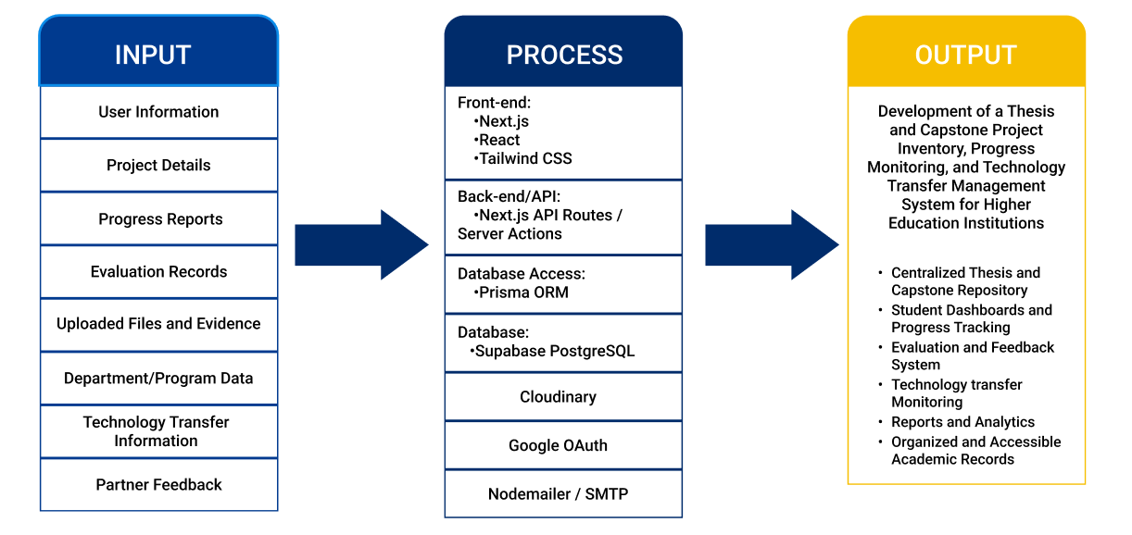
Figure 1 Input-Process-Output Diagram
Input
The input gathers all necessary data required to manage thesis and capstone projects within the system.
- User Information: includes details of students, advisers, administrators, and external stakeholders used for access and identification.
- Project Details: contains information about the thesis or capstone project such as title, abstract, and members.
- Progress Reports: records updates on project development and milestone completion.
- Evaluation Records: includes adviser or panel feedback and assessment results.
- Uploaded Files and Evidence: consists of documents such as proposals, manuscripts, and supporting files.
- Department/Program Data: provides organizational information used for classification and reporting.
- Technology Transfer Information: contains data related to project deployment and potential partners.
- Partner Feedback: includes responses and evaluations from external stakeholders regarding project utilization.

PROCESS
This phase represents the system process responsible for handling and transforming the input data into meaningful research management outputs.
- Front-end (Next.js, React, Tailwind CSS): Processes user interactions and renders the responsive interface for stakeholder dashboards.
- Back-end/API (Next.js API Routes / Server Actions): Executes the core system logic and processes requests for data management and monitoring.
- Database Access (Prisma ORM): Facilitates the communication process between the application logic and the data storage layer.
- Database (Supabase PostgreSQL): Manages the systematic storage and organization of institutional project records and user information.
- Cloudinary: Handles the delivery and optimization of your images, videos, and logos.
- Google OAuth: Manages the secure authentication process for verified user access.
- Nodemailer / SMTP: Processes and delivers automated notifications, updates, and reminders to users.

OUTPUT
The output presents the results generated after the system processes the input data.
- Centralized Thesis and Capstone Repository: organized storage of academic outputs.
- Student Dashboards and Progress Tracking: real-time monitoring of project development.
- Evaluation and Feedback System: structured assessment and communication between users.
- Technology Transfer Monitoring: tracking of project deployment and utilization.
- Reports and Analytics: generated insights for decision-making and evaluation.
- Organized and Accessible Academic Records: improved accessibility and management of project data.

  - Statement of the Problem
General Problem
Higher education institutions struggle with decentralized research management and inconsistent progress monitoring due to underutilized digital tools (Hailitik et al., 2025). Furthermore, a lack of structured technology transfer and weak industry ties prevent academic discoveries from reaching real-world application, particularly in Philippine state universities (Goncharenko, 2021; Sarita, 2025). Therefore, this study addresses the urgent need for a centralized system to bridge the gap between academic output and industry utilization.
Specific Problems
- Absence of a digital inventory repository for organizing and managing thesis and capstone project outputs.
- Lack of an efficient system for monitoring the progress of ongoing research and development projects.
- Limited mechanisms for facilitating technology transfer between academic institutions and industry or community partners.
- Difficulty in generating comprehensive dashboards and reports for research tracking, extension activities, and collaboration.
- Need for a system that meets quality standards in terms of functionality, usability, reliability, performance efficiency, and security based on ISO/IEC 25010.

  - Objectives of the Study
To design and develop an integrated system for inventory, progress monitoring, and technology transfer of thesis and capstone project outputs in higher education institutions.
Specific Objectives
- To develop a digital inventory repository for thesis and capstone projects
- To implement a progress monitoring system for ongoing research and development
- To create a technology transfer module linking academic outputs to industry and community partners
- To provide dashboards and reports for research, extension, and industry collaboration
- To evaluate the system using ISO/IEC 25010 quality standards

  - Significance of the Study
The significance of the study will be useful to the following:
- Students: This study is important for students because provides a centralized platform for them to manage their final projects, allowing for easier document submission, milestone tracking, and timely feedback from advisors. It reduces confusion and delays by maintaining organized records and offers a technology transfer section to showcase their work to external partners for possible real-world application.
- Advisers and Panel: The system offers a simplified method for monitoring student progress and reviewing work, eliminating the need for manual tracking or unorganized communication. By centralizing project information, it enables advisers and panel members to make more informed decisions during project evaluations and final defenses.
- Department Chairs: The study provides department chairs with detailed reports on student progress, completion rates, and overall project performance. This data assists in identifying academic trends or delays, facilitating better departmental management and program improvement.
- Library Personnel: The system serves as an organized digital repository that simplifies the archiving and retrieval of completed thesis and capstone projects. By providing a centralized home for final manuscripts and metadata, it helps library staff manage academic records more efficiently and ensures that research outputs are easily accessible for future reference.
- Research Head: For the research head, the system serves as a primary core for storing and managing institutional research, making it easier to track and report on activities necessary for school ratings. The technology transfer module specifically helps the research head connect academic projects with outside partners to enhance the institution's societal impact.
- Industry Partners: Businesses, government offices, and community groups gain an efficient way to discover student projects that offer solutions to specific problems. This collaboration helps transform academic research into real-world products or services that benefit the local economy and community.
- System Admin: This study is useful for system administrators because it provides an integrated platform for high-level management of the system's technical operations. It supports user account management, role-based access control, system maintenance, and notification management. The study enables administrators to preserve the reliability, security, and integrity of the digital infrastructure more effectively.
- Future Researchers: The study acts as a foundation for developing or improving systems related to project management and technology transfer. The research design, results, and methodologies serve as a guide for future updates and contribute to the fields of information systems and educational technology.

  - Scope and Limitations

    - Scope of the Study
This study focuses on the design and development of a Thesis and Capstone Project Inventory, Progress Monitoring, and Technology Transfer Management System for Higher Education Institutions, specifically intended for use at the University of Science and Technology of Southern Philippines – Jasaan Campus. The system aims to simplify research management by providing a centralized platform to organize and store final projects, including titles, abstracts, author names, and supporting digital files. It incorporates a progress tracking feature that allows students, advisors, and administrative staff to monitor project development through established milestones and timelines, ensuring timely completion of academic requirements.
The system is designed to support multiple user roles including students, advisors, staff, and external partners each with specific access levels and functional tasks. Key features include structured file uploading, organized data storage, and a search function for easy document retrieval. To assist in institutional oversight and decision-making, the platform also provides dashboards and reports that offer visual summaries and data-driven insights into research performance.
Additionally, the study includes a dedicated technology transfer module to bridge the gap between academic innovation and real-world application by connecting school projects with businesses, government offices, and community organizations. This module facilitates partner matching, tracks project utilization, and monitors the societal impact of research outputs. The system is developed as a web-based application and will be evaluated using the ISO/IEC 25010 quality standards to verify its functional suitability, usability, reliability, and performance efficiency.

    - Limitations of the Study
Despite its intended contributions, this study is subject to several limitations. The system is developed specifically for the University of Science and Technology of Southern Philippines – Jasaan Campus and is not currently intended for use by other institutions. Consequently, its features are tailored to the specific administrative rules and workflows of the Jasaan campus.
The system does not incorporate Artificial Intelligence (AI) functionalities, such as automated recommendations, predictive analytics, plagiarism detection, or AI-based monitoring tools. Instead, all system operations rely on manual user input, predefined task sequences, and human evaluation. This focus ensures the study remains centered on the core functional architecture of the management system rather than advanced automation technologies.
Furthermore, while the platform includes a technology transfer module, it cannot guarantee that external partners will officially launch or adopt the projects, as such outcomes depend on external factors beyond the system's control. The scope of management is strictly limited to student thesis and capstone projects and does not extend to faculty research, academic journals, or projects funded by external organizations.
In terms of technical features, the system does not facilitate student consultations or offer advanced real-time communication tools like live chat or video conferencing, as the primary focus is strictly on organization, milestone tracking, and reporting. The reliability of the generated results depends entirely on the accuracy and completeness of the data entered by users. Additionally, integration with third-party platforms such as Google Scholar or Scopus may be limited due to technical and resource constraints.
Lastly, while basic security measures are implemented, the system may not be protected against all advanced cybersecurity risks. The evaluation is limited to specific ISO/IEC 25010 standards and short-term user testing, rather than a long-term assessment of how the system performs over an extended period or on a very large scale.

1.7 Definition of Terms
To ensure clarity and a shared understanding of the concepts discussed in this study, the following terms are operationally defined based on their specific use within the proposed system:

- Adviser and Panel Member: Faculty users assigned to supervise project workflows, provide structured feedback on milestone submissions, and utilize the system to calculate and record final defense grades.
- Application Programming Interface (API): The set of protocols (specifically Next.js API routes) used to facilitate communication and data exchange between the system's frontend interface and the backend database.
- Capstone Project and Thesis: In the context of this study, this refers to the mandatory final academic research outputs produced by students that are systematically uploaded, monitored, evaluated, and archived within the platform.
- Cloudinary: The external cloud-based service integrated into the system used for the secure storage, optimization, and delivery of user media assets and visual files.
- Department Chair: The academic leaders responsible for monitoring student progress, reviewing departmental analytics, and managing the technology transfer module by matching high-impact projects to industry needs and tracking deployment impact.
- Digital Inventory Repository: The centralized, web-based storage component of the system designed for the organized archiving, indexing, and retrieval of approved manuscripts, metadata, and supporting digital files.
- Digital Rubric: The automated, structured grading tool integrated into the system that panel members use to evaluate student outputs and automatically calculate final defense scores.
- Google OAuth: The secure authentication protocol integrated into the system to verify user identities and manage secure login access across all institutional and external user roles.
- Industry Partner: External stakeholders—including businesses, government offices, and community organizations—who are granted specific system access to browse high-impact student research, submit implementation requests, and provide feedback on deployed projects.
- ISO/IEC 25010: The standard software quality evaluation framework utilized in this study to quantitatively assess the developed system based on its functional suitability, usability, reliability, and performance efficiency.
- Library Personnel: The designated staff responsible for auditing, validating, and permanently archiving the finalized thesis manuscripts and indexing them for the system's search module.
- Next.js and React: The core front-end web development frameworks utilized to build the system's responsive user interface and stakeholder dashboards.
- Nodemailer / SMTP: The automated email communication service used by the system to immediately dispatch real-time alerts, progress updates, and defense schedules to relevant stakeholders.
- Prisma ORM: The database access layer that facilitates efficient and structured communication between the system's application logic and the database storage.
- Progress Monitoring: The active tracking feature within the platform that allows students, faculty, and administrators to oversee ongoing project development through predefined milestones, document submissions, and structured real-time feedback.
- Rapid Application Development (RAD): The iterative software engineering methodology adopted in this study, which focuses on quick prototyping and continuous user feedback to efficiently build and test the system's core modules.
- Research Head: The administrative user with institutional oversight, utilizing a centralized dashboard to monitor project milestones, review departmental analytics, and oversee technology transfer metrics.
- Role-Based Access Control (RBAC): The security mechanism implemented within the system that restricts data access and platform functionalities based on the specific assigned role of the user.
- Supabase (PostgreSQL): The primary cloud-based backend and database service used for the secure, systematic storage of institutional project records, user information, and manuscript files.
- System Admin: The user role responsible for the high-level management of the platform’s technical operations, including user account creation, role-based access control, and system maintenance.
- System Usability Scale (SUS) and User Acceptance Testing (UAT): The supplementary evaluation metrics employed to formally measure the platform's practical workflow integration, user satisfaction, and overall ease of use among its intended stakeholders.
- Technology Transfer: The systematic process facilitated by the system’s dedicated module that bridges the gap between academic innovation and real-world application by matching finalized student projects with appropriate external partners.
- Web-Based Application: A software program that runs on a web server and is accessed by stakeholders through a web browser over the internet, serving as the primary delivery method for the ThesisTrack platform.
CHAPTER II
REVIEW OF RELATED LITERATURE

This chapter presents a review of related literature and studies relevant to the study. A comprehensive examination of both foreign and local sources was conducted to understand existing systems, practices, and approaches in research repositories, project management, academic monitoring, and technology transfer. This review provides a foundation for the study by identifying recent developments, key features, and limitations, particularly in terms of integration, efficiency, and real-world application. It also highlights existing gaps such as the lack of centralized platforms, manual monitoring, and limited technology transfer, which support the need for a more integrated and effective solution.

2.1 Research Repository and Inventory Systems
Research repository and inventory systems are essential in higher education because they preserve academic outputs and make institutional knowledge easier to retrieve, verify, and reuse. For thesis and capstone projects, repository systems serve not only as storage locations but also as evidence of student learning, departmental productivity, and institutional research direction. The common problem addressed by the studies in this area is the continued dependence of many institutions on hardbound manuscripts, scattered digital files, and manual recordkeeping practices. These approaches make retrieval slow, expose documents to physical damage or loss, and limit the ability of students, faculty, and administrators to trace previous works. The reviewed studies therefore share a common objective: to improve the organization, accessibility, and protection of academic records through digital systems.
Perante et al. (2024) directly addressed this issue by designing and developing a thesis and capstone project manuscript archiving management system for Eastern Visayas State University Ormoc Campus. The study was motivated by the limitations of traditional hardbound storage, particularly the difficulty of preserving, searching, and retrieving completed manuscripts. Using system development approaches associated with Agile and Rapid Application Development, the researchers created a web-based digital archive intended to support faster access to student research outputs. The results showed that digital archiving can improve the preservation and accessibility of thesis and capstone manuscripts. This study is significant because it demonstrates how a local higher education institution can shift from physical archives to a more organized digital environment. However, its main limitation is that it treats the manuscript largely as a completed record. It does not deeply address what happens before archiving, such as proposal submission, adviser feedback, progress tracking, revision history, defense evaluation, or post-completion technology transfer.
The focus on improving records is also reflected in the work of Reyes et al. (2024), who assessed the efficiency of computerized student record management systems in higher education institutions. While their study was not limited to thesis or capstone manuscripts, it supports the argument that academic institutions need reliable computerized systems to reduce duplication, improve data accuracy, and strengthen long-term record integrity. Their study proposed a computerized management model that could improve administrative efficiency and user interaction. Compared with Perante et al. (2024), Reyes et al. (2024) approached the issue at a broader institutional records level rather than at a thesis-specific level. This broader scope is useful because it highlights the importance of structured data management, but it also reveals a limitation: general student record systems do not fully capture the milestone-driven nature of thesis and capstone projects, where documents pass through proposal, revision, defense, approval, archiving, and possible utilization stages.
Liu et al. (2021) expanded the discussion from basic archiving to scientific research project management by designing and applying a science and technology project management information system for educational institutes. Their study analyzed user needs, business requirements, system feasibility, and system-level design, then developed a layered architecture to support secure and consistent research management. Its contribution lies in showing that research-related information systems must be designed with attention to data consistency, information security, and institutional workflow. In relation to the previous studies, Liu et al. (2021) offered a more technically structured approach than ordinary repository systems. However, the system was designed mainly for scientific research project administration and institutional research office tasks. It does not specifically address the student-centered supervision process of thesis and capstone projects, where advisers, panels, students, department chairs, library personnel, and external partners may need different access levels and workflow responsibilities.
The institutional repository perspective is further supported by Safdar (2021), who examined the experience of Library and Information Science professionals in Pakistan in creating institutional repositories using DSpace. The study explored success factors, implementation problems, and possible solutions through multiple phases, including literature review and professional experience-based investigation. Safdar (2021) emphasized that institutional repositories are valuable because they support academic communication, research preservation, and access to scholarly outputs. This strengthens the repository argument made by Perante et al. (2024), but it also introduces an important operational issue: successful implementation depends on staff knowledge, technical capacity, training, and institutional support. Thus, even when a repository platform is available, it may not function effectively if users are not prepared to maintain it. For the current study, this finding is important because a repository should not only be technically functional; it should also be aligned with the roles and actual abilities of the users who will operate it.
Doromal and Soberano (2023) presented a more specialized repository system through their Capstone Archiving Management System with Citation and Reference Generator. Their objective was to help students electronically access, search, and use capstone studies while also supporting citation and reference generation. The study involved user acceptance testing among students, faculty, library personnel, and other users familiar with capstone activities. The results showed strong agreement in usefulness, ease of use, and computer system usability, indicating that users found the system helpful and practical. Compared with Safdar (2021), who focused on institutional repository implementation using DSpace, Doromal and Soberano (2023) designed a system closer to student capstone needs. However, despite its usefulness, the system still centers on archiving and reference support. It does not provide a complete active project management process, such as milestone monitoring, adviser review, defense tracking, or technology transfer follow-up.
Batoon et al. (2022) moved repository development a step further by integrating plagiarism checking and prescriptive analytics into THESISQUO, a research management system for thesis studies. The study aimed to provide an online repository while also addressing the problem of plagiarism and limited research guidance. Its evaluation using ISO/IEC 25010 showed that the system was positively rated in relevant quality characteristics. This study differs from the earlier archive-centered systems because it attempts to add analytical functions to the repository environment. However, its limitation remains similar: the system is stronger in storing, checking, and analyzing documents than in managing the full thesis or capstone lifecycle. It does not fully integrate day-to-day adviser supervision, milestone-based progress monitoring, department-level reporting, library archiving approval, and structured industry or community partner engagement.

2.2 Monitoring and Evaluation in Academic Systems
Monitoring and evaluation systems are important because thesis and capstone projects depend on continuous supervision, timely feedback, milestone completion, and decision-making by advisers, panels, and administrators. While repository systems solve the problem of storing completed outputs, they do not automatically solve delays, weak communication, inconsistent adviser feedback, or lack of follow-up during project development. The studies in this section therefore address a different but related problem: how institutions can track academic progress, identify students or projects at risk, and improve the quality of supervision and evaluation. This section builds on the previous discussion by showing that an effective thesis and capstone management system must support both archiving and active monitoring.
Lando and Wambua (2025) examined digital solutions for graduate supervision and provided a critical analysis of thesis management systems. Their work was motivated by supervision challenges such as delayed feedback, weak communication, stagnation of graduate students, and administrative bottlenecks. The objective of the study was to analyze how thesis management systems can improve graduate supervision by organizing supervisor-student interactions and providing clearer oversight. Their discussion showed that digital thesis management systems can strengthen transparency and reduce delays when supervision tasks are supported by structured workflows. This study is closely related to the current research because it confirms that supervision is not only a communication issue but also a management issue. However, its limitation is that it mainly focuses on the graduate supervision relationship and does not fully incorporate repository archiving, library validation, departmental dashboards, or technology transfer mechanisms.
Qazdar et al. (2023) approached monitoring from the perspective of learning analytics. Their study proposed student performance indicators based on data generated within Learning Management Systems to support continuous monitoring. The researchers used a case study involving a Web Technologies course on an e-campus platform, transforming student interactions and academic activities into indicators that could help faculty identify underperforming students, project progress, and anticipate academic risk. This study supports the findings of Lando and Wambua (2025) by showing that monitoring becomes more useful when student activity is translated into meaningful indicators. However, Qazdar et al. (2023) focused on course-based learning analytics rather than thesis or capstone project development. A regular course usually follows a predictable class structure, while thesis and capstone projects involve proposal approval, chapter submissions, prototype development, defense scheduling, revisions, final manuscript compliance, and archiving. Therefore, while learning analytics offers useful monitoring principles, these principles must be adapted to the unique workflow of research project management.
Regla and Ballera (2023) extended the monitoring discussion to the institutional research productivity level. Their study aimed to design a research data collection system, apply Natural Language Processing techniques to support retrieval and monitoring of research productivity, and generate visualizations and analytics from institutional research data. The study shows how digital systems can help higher education institutions organize research outputs and convert stored information into useful analytics for decision-making. Compared with Qazdar et al. (2023), who focused on individual student progress within an LMS, Regla and Ballera (2023) focused more on institutional research productivity and reporting. This is valuable for administrators because it supports strategic planning and visibility of research performance. Nevertheless, its limitation for the present study is that it monitors productivity at a broader institutional level rather than managing the detailed, project-level activities of students and advisers. It does not fully address how individual thesis groups move from one milestone to another or how adviser feedback and evaluation records are handled during project development.
The need for meaningful follow-up is emphasized by Hailitik et al. (2025), who analyzed the effectiveness of academic monitoring and evaluation on the length of study at Nusa Cendana University. Using a qualitative case study approach, the researchers gathered data through in-depth interviews, participant observation, and documentation studies. Their results showed that academic monitoring and evaluation were not fully effective in influencing timely student completion because of minimal academic guidance, weak follow-up on evaluation results, suboptimal use of academic information systems, and limited intervention for delayed students. This finding strengthens the argument that monitoring cannot be reduced to the existence of a system alone. Even when academic information systems are present, they must be actively used to support follow-up, intervention, and accountable decision-making. For the current study, this means that progress monitoring should not simply display status updates; it should create a clearer workflow for submissions, adviser review, milestone tracking, notifications, and reports.
Simard (2021) contributed another important perspective by examining the implementation of project management principles in a capstone design course. The study focused on practices such as scheduling, reporting, communication, and structured project organization. Its findings showed that applying project management practices can improve capstone outcomes because students become more guided in planning and completing their work. This study relates closely to Hailitik et al. (2025) because both point to the importance of structure and follow-through. However, Simard (2021) concentrated more on pedagogical project management practices than on a dedicated software platform that can automate, document, and institutionalize these practices. This creates a practical gap: project management principles may improve capstone performance, but without a system that records milestones, stores submissions, tracks evaluations, and generates reports, implementation may still depend heavily on individual advisers and manual coordination..

2.3 Innovation, Technology Transfer, and Research Advancement Systems
Innovation and technology transfer are important extensions of thesis and capstone management because student research is not only an academic requirement but may also contain practical solutions for institutional, community, or industry problems. A project that is properly monitored and archived can still remain underutilized if there is no system for identifying its potential users, recording partner interest, tracking implementation, or reporting its impact. The studies in this section therefore address the problem of connecting academic outputs with broader research advancement and real-world application. This section continues the flow of the review by moving from storage and monitoring toward the final stage of the research lifecycle: utilization, collaboration, and innovation development.
Chio et al. (2022) developed ThesisIT, a web-based university thesis management portal with a defense scheduling system. The study was designed to make the thesis cycle easier to follow and complete, particularly by automating oral defense scheduling. The researchers implemented automated scheduling using a genetic algorithm and evaluated the system through usability testing. The results indicated that the system improved administrative efficiency and supported document management and defense scheduling. This study is relevant because it demonstrates how a specific bottleneck in thesis administration, such as scheduling, can be addressed through a digital system. In relation to the monitoring studies discussed earlier, ThesisIT shows the value of automation in reducing delays during the defense stage. However, its limitation is that it focuses mainly on the thesis cycle up to defense-related processes. It does not fully extend to post-defense archiving, technology transfer monitoring, or partner engagement after the project has been completed.
Goncharenko (2021) shifted the discussion from thesis administration to the broader university innovation ecosystem. The study proposed a conceptual model of a hackathon ecosystem for technology transfer in a higher education institution. Its objective was to promote collaboration, public visibility, creativity, and the movement of university-generated ideas toward practical application. Unlike Chio et al. (2022), which presented a functional thesis portal, Goncharenko (2021) offered a conceptual ecosystem model centered on innovation events and collaboration. This study is useful because it shows that technology transfer is not merely a database function; it also requires interaction among students, mentors, institutions, and external stakeholders. However, the study remains largely conceptual and does not provide a working software platform for tracking research outputs, monitoring partner interest, or documenting implementation outcomes over time.
Huang (2025) further examined technology transfer in higher education by focusing on how data-driven collaboration and institutional processes can strengthen research innovation. The study used survey and workshop-based insights to propose a flexible implementation plan for technology transfer in higher education. This connects with Goncharenko (2021) because both studies recognize that innovation requires structured collaboration between the university and external actors. Huang (2025), however, places stronger attention on data-informed teamwork and implementation planning. Its limitation is that it remains focused on strategy and process improvement rather than on a specific technical platform that links research inventory, progress monitoring, partner matching, and utilization tracking. Thus, while it provides important guidance on how higher education institutions can think about technology transfer, it does not fully solve the system-level problem of managing student research outputs from development to adoption.
Palavesm and Joorel (2022) discussed Research Information Management Systems through the implementation of IRINS in Indian higher education institutions. Their study described challenges in setting up research information management, including identifying nodal officers, collecting faculty profile information, retrieving scholarly communication activities from internal and external sources, and providing training to institutional personnel. This study is significant because it shows that research advancement requires organized data infrastructure and trained personnel. Compared with Huang (2025), which emphasized technology transfer planning, Palavesm and Joorel (2022) focused on institutional research information management and visibility. However, IRINS and similar research information systems are generally designed for faculty research profiles, scholarly outputs, and institutional productivity. They are not primarily designed for managing student thesis and capstone projects at the granular level of submissions, adviser reviews, defense outcomes, final repository approval, and partner matching.
Sarita (2025) provided a Philippine-specific view of technology transfer in state universities and colleges. The study examined the technology transfer landscape in Philippine SUCs, particularly in the Davao Region and Davao Oriental State University, and highlighted barriers such as weak industry linkages, bureaucratic inefficiencies, limited institutional capacity, regulatory constraints, and inadequate funding. This study is particularly important for the current research because it situates technology transfer within the Philippine higher education context. It supports the idea that student and institutional research outputs may fail to reach practical users not because they lack value, but because universities often lack dedicated mechanisms, personnel, resources, and industry connections to move research toward application. However, while Sarita (2025) provides a strong policy and ecosystem-based analysis, it does not present a software system that can operationalize technology transfer at the level of project records, partner browsing, implementation requests, feedback, and impact tracking.
Across these innovation and technology transfer studies, previous researchers have already accomplished important work in three areas. First, they have shown that specific administrative problems in thesis management, such as defense scheduling and document handling, can be improved through web-based systems. Second, they have established that innovation requires structured collaboration between universities and external stakeholders, not only internal academic evaluation. Third, they have demonstrated that research information management systems can increase visibility, organization, and institutional reporting. These accomplishments provide a strong foundation for the present study because they show that digital tools and institutional processes can make academic research more organized and more useful.
Despite these accomplishments, common gaps remain across the reviewed studies. Many systems are fragmented, focusing only on one stage of the research lifecycle. Repository systems preserve completed outputs but often neglect active supervision and progress tracking. Monitoring systems improve oversight but usually do not connect their data to final archiving or technology transfer. Technology transfer studies explain the importance of innovation ecosystems and industry linkages, but many remain conceptual or policy-oriented and do not provide an integrated project-level software tool. In addition, research information management systems often focus on faculty publications and institutional productivity rather than student thesis and capstone projects. These limitations show that the problem is not simply the absence of digital tools, but the absence of a unified workflow that connects project inventory, milestone monitoring, evaluation, archiving, reporting, and partner engagement.
The current study is justified by these gaps because it proposes a system that treats thesis and capstone projects as a complete lifecycle rather than as isolated records. The proposed Thesis and Capstone Project Inventory, Progress Monitoring, and Technology Transfer Management System intends to integrate repository management with progress monitoring, adviser and panel evaluation, dashboard reporting, and technology transfer tracking. By doing so, it addresses the storage limitations identified in repository systems, the follow-up weaknesses identified in monitoring studies, and the lack of operational tools identified in technology transfer literature. The system does not claim to guarantee external adoption of student projects, since industry acceptance depends on factors beyond the software itself. However, it can provide the institutional mechanism needed to make projects visible, organized, traceable, and easier to connect with potential partners.
The reviewed literature presents a clear progression in the development of academic research management systems, beginning with digital repository and inventory platforms, expanding into monitoring and evaluation systems, and eventually progressing toward innovation and technology transfer initiatives. Studies on repository and inventory systems demonstrate that digital archiving greatly improves document accessibility, long-term preservation, and institutional record management. Over time, these systems have evolved from simple storage platforms into more advanced solutions that incorporate search functions, citation support, plagiarism detection, analytics, and secure data handling. Despite these developments, most repository systems still focus primarily on storing completed outputs rather than supporting research projects throughout their entire academic and administrative lifecycle. As a result, an important gap remains in managing research activities while projects are still in progress, not only after they have been completed.
Furthermore, studies on monitoring and evaluation systems emphasize that academic progress and project completion improve when supervision, analytics, performance indicators, and project management practices are systematically organized. Existing literature shows that learning analytics can help identify students at risk of delays, productivity monitoring systems can support institutional reporting, and structured project management approaches can strengthen coordination in capstone courses. Although these systems contribute significantly to improving academic oversight, many were designed for specific purposes such as supervision management, course monitoring, institutional productivity analysis, or instructional support. Because of this, they often fail to provide a unified environment capable of handling the full thesis and capstone workflow from proposal development to final completion. In addition, even effective monitoring becomes limited when completed projects remain archived without opportunities for practical application or external collaboration.
This limitation naturally leads to the growing importance of innovation and technology transfer systems, which aim to connect academic research with industry, government agencies, and community stakeholders. The reviewed studies emphasize the value of collaboration, commercialization, innovation ecosystems, and institutional partnerships in increasing the real-world impact of student research. However, many of these initiatives remain conceptual, policy-oriented, or focused mainly on institutional-level innovation management rather than providing practical systems that integrate repository management, progress monitoring, and technology transfer into a single platform. Consequently, although repository systems preserve knowledge, monitoring systems guide project completion, and technology transfer initiatives promote practical utilization, these functions are still commonly implemented as separate processes. The present study addresses this gap by proposing an integrated web-based platform that combines repository management, progress monitoring, evaluation support, and technology transfer into a unified system specifically designed for thesis and capstone management in higher education institutions, particularly within the USTP Jasaan Campus.

CHAPTER III
RESEARCH DESIGN & METHODOLOGY

This chapter details the research methodology employed to facilitate the systematic development and accurate evaluation of the proposed system. It outlines the foundational research design, the phased development approach, and the specific data collection methods utilized to capture both technical and user-centric requirements. Furthermore, this section discusses the comprehensive procedures for gathering data from institutional and external stakeholders, alongside the statistical and thematic frameworks used to analyze the results and ensure the system's overall efficacy.

3.1 Research Design
This study will adopt a Developmental Research Design, focusing on the systematic design, development, and evaluation of an integrated management system. This approach is not merely descriptive but is a proactive methodology aimed at building a functional tool to solve specific institutional challenges. The research will be structured into two distinct, interconnected phases to ensure technical efficacy and alignment with academic needs.
Phase 1 will focus on System Development, involving the accurate gathering of requirements from students, advisers, administrators, and industry partners to ensure the system addresses actual user needs. During this phase, the researchers will design and build five core modules: the Student Module, Adviser Module, Admin Module, Industry Partner Module, and the Technology Transfer Module. Following development, the research will transition into Phase 2, which consists of the System Evaluation to formally measure the quality of the application. This assessment will be grounded in the ISO/IEC 25010 quality standards, specifically focusing on the criteria of functional suitability, performance efficiency, usability, reliability, and security. In addition, the study will utilize the System Usability Scale (SUS) to measure usability and User Acceptance Testing (UAT) to determine whether the system meets the needs and expectations of its intended users.

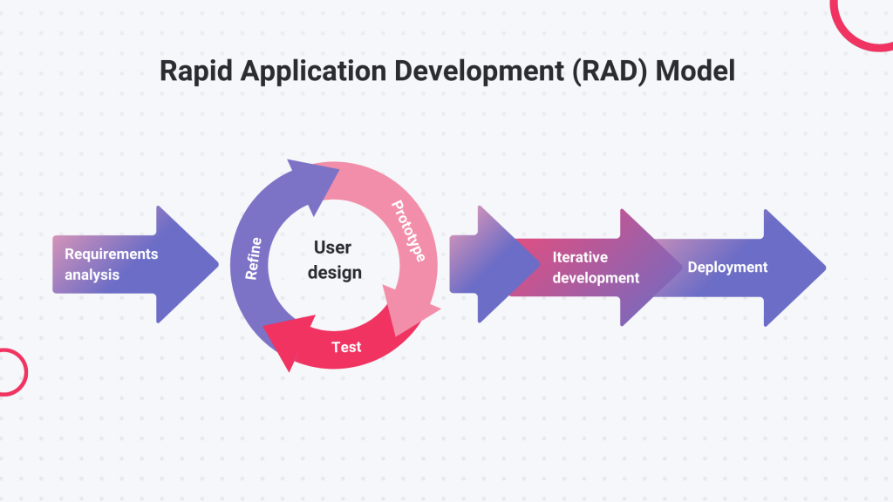
Figure 2 – RAD Model for System Design

To support this developmental design, the study will utilize the Rapid Application Development (RAD) model. This model was selected for its emphasis on iterative prototyping and continuous user feedback, allowing the researchers to refine features quickly and ensure the final product matches user requirements within a short development cycle.

The development process will follow multiple phases:
Planning – The researchers will identify existing problems in thesis management and define system objectives. Initial requirements will be collected from students, advisers, and school leaders. The team will also engage external stakeholders, such as industry partners, to ensure the system effectively supports technology transfer.
Analysis – Collected data will be examined to determine detailed system requirements. Researchers will analyze user needs and process flows to ensure the design aligns with institutional operations.
Design – The system architecture, database structure, and user interface will be created. Technical diagrams, including system flows and database designs, will be prepared to guide development.
Development – The system will be built using appropriate front-end, back-end, and database tools. Core features, such as the project inventory and technology transfer modules, will be integrated to make the system functional.

Testing – Once development is finished, the application will undergo rigorous testing to identify and correct errors or inconsistencies. Feedback will be used to check performance and implement necessary improvements.
Implementation – After testing and polishing the system, the final version will be prepared for launch and introduced to selected users within the research department. Users will interact with the system in real-life situations to provide further performance feedback.
Evaluation – The finished application will be assessed by users to measure functionality, ease of use, and overall performance based on ISO/IEC 25010 standards. Results will be gathered through standardized survey questionnaires and direct observations to adjust the system.

UML Diagrams

System Architecture
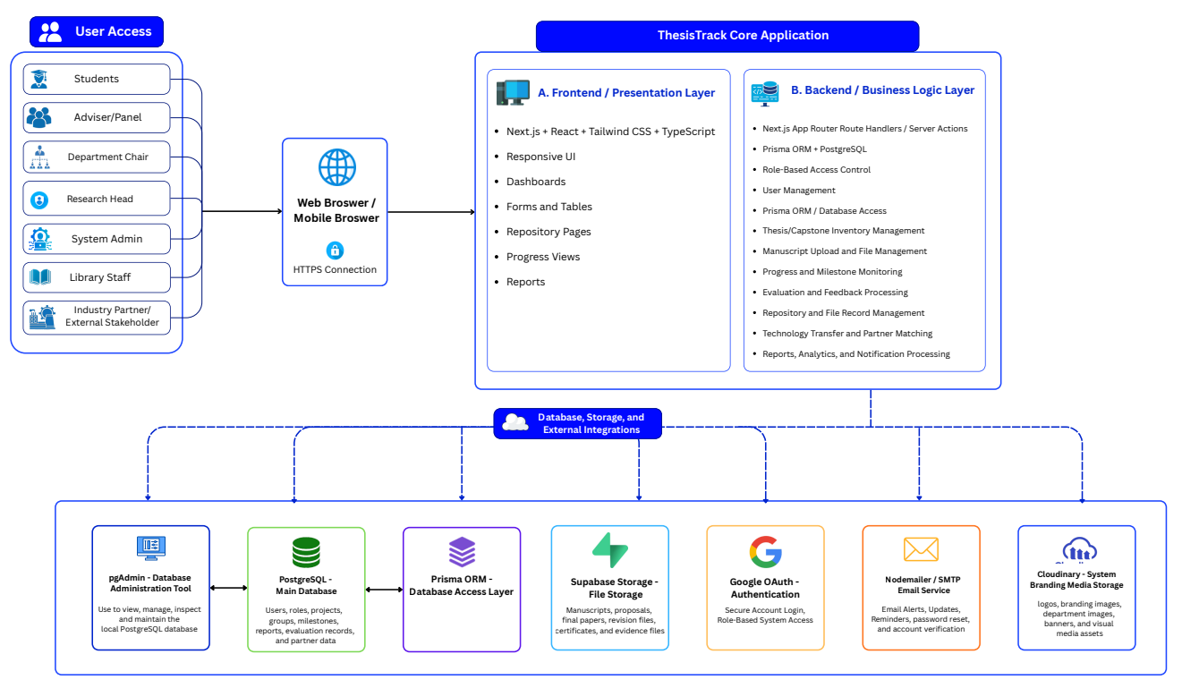
Figure 3 – System Architecture of ThesisTrack
Figure 3 illustrates the overall architecture of the ThesisTrack platform, showing how users interact with the frontend, backend, databases, and integrated external services to support thesis and capstone management operations.

- Client-Server Architecture: The system follows a web-based client-server architecture accessible through desktop and mobile browsers.
- Multi-User Access: Supports multiple user roles including students, advisers, department chairs, research heads, system administrators, library personnel, and industry partners.
- Frontend Layer: Built using Next.js, React, Tailwind CSS, and TypeScript to provide responsive and interactive user interfaces.
- Backend Layer: Handles authentication, business logic, project management, repository workflows, evaluation processing, and notification management.
- Database Management: Uses PostgreSQL with Prisma ORM for centralized and structured data handling.
- Document Storage: Integrates Supabase Storage for storing thesis manuscripts and related project documents.
- Media Management: Utilizes Cloudinary for handling images, logos, and certificate assets.
- Authentication Service: Implements Google OAuth for secure login and account verification.
- Email Notification Service: Uses Nodemailer with Gmail SMTP for alerts, verification emails, and notification delivery.
- Integrated Functions: Supports repository management, progress monitoring, analytics, evaluation tracking, and technology transfer coordination within a unified platform.

Context Diagram
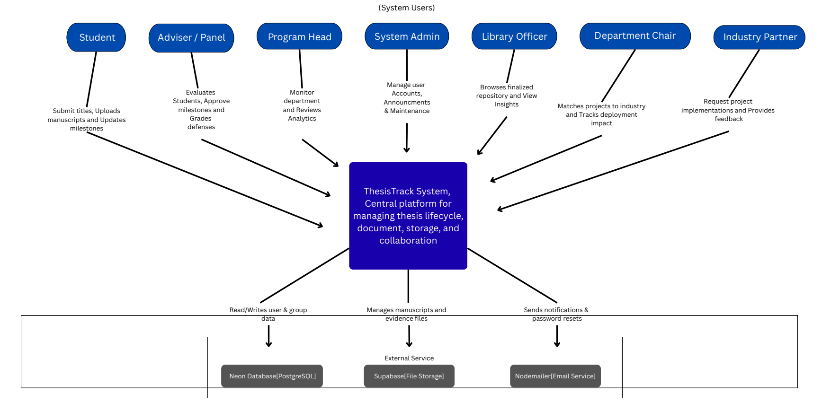
Figure 4 – User Interaction and External Service Context

Figure 4 illustrates the high-level interaction between the ThesisTrack platform, its primary users, and connected external services. It shows how users such as students, advisers, department chairs, administrators, library personnel, and industry partners interact with the system for project management, monitoring, evaluation, repository access, and collaboration. The diagram also presents the integration of external services, including the database, file storage, and email notification components that support the overall operation of the platform.

Data Flow Diagram
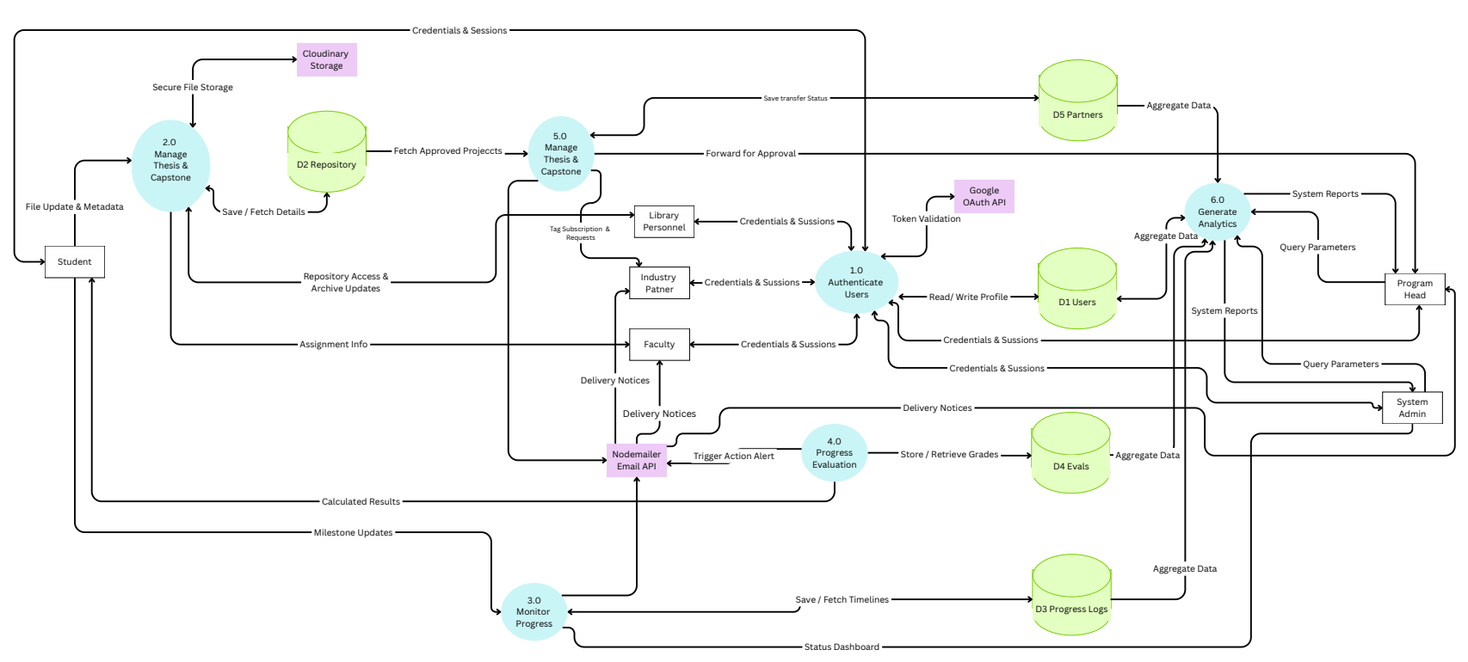
Figure 5 - Integrated Data Flow and Process Interaction

Figure 5 presents the integrated flow of data and processes within the ThesisTrack platform. It illustrates how users, core system modules, databases, and external services interact to support authentication, thesis and capstone management, progress monitoring, evaluation, archiving, analytics generation, and technology transfer activities. The diagram also demonstrates how information is securely processed, stored, retrieved, and distributed across the system to support institutional research management and collaboration workflows.

System Flowchart

Student
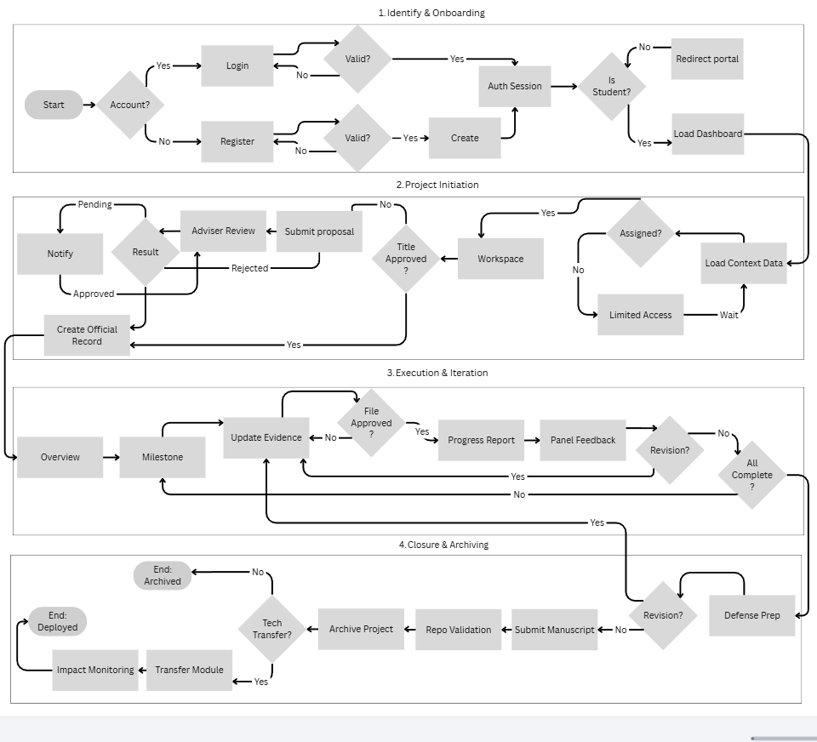

Figure 6 – Student Research Project Workflow and Progress

Figure 6 illustrates the workflow followed by students throughout the thesis and capstone process within the ThesisTrack system. It presents the sequence from account authentication and project initiation to milestone monitoring, adviser feedback, manuscript revision, final submission, archiving, and potential technology transfer. The diagram highlights how students interact with the system during project development while supporting continuous monitoring, evaluation, and institutional documentation.

Adviser/Panel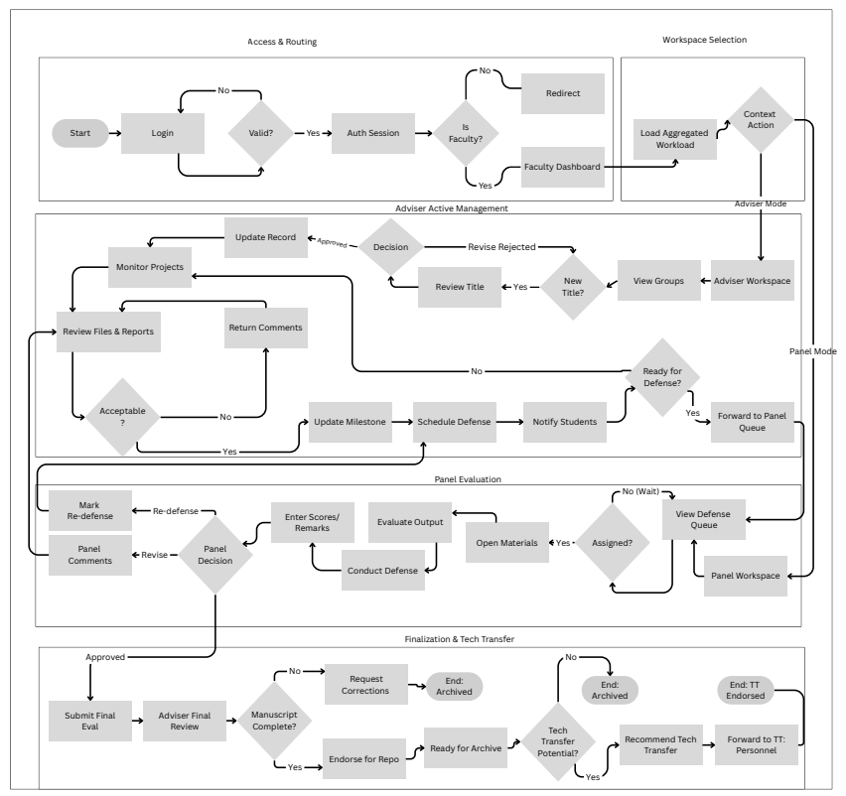

Figure 7 - Adviser and Panel Evaluation Workflow

Figure 7 illustrates the workflow of advisers and panel members in managing, evaluating, and monitoring thesis and capstone projects within the ThesisTrack system. The process includes project review, milestone evaluation, defense scheduling, panel assessment, revision management, final approval, and technology transfer endorsement. The diagram highlights how faculty members interact with the platform to support continuous supervision, structured evaluation, and institutional archiving of research outputs.

Department Chairman
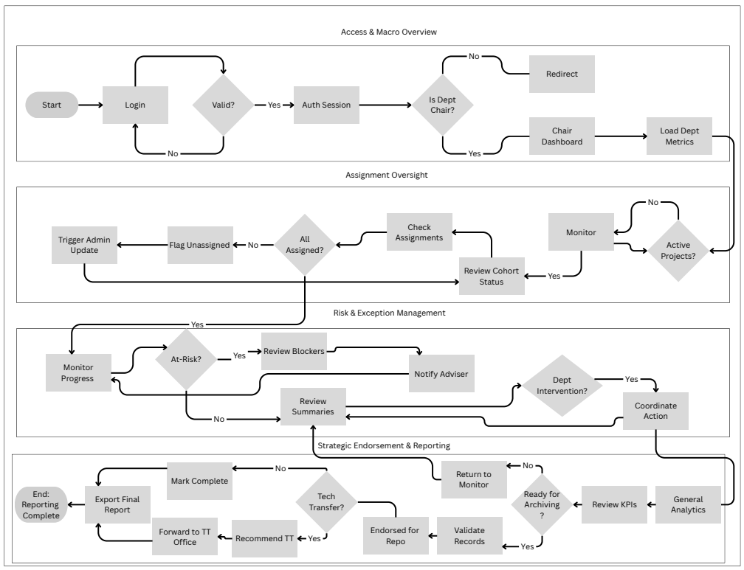

Figure 8 - Department Chair Monitoring and Research Oversight Workflow

Figure 8 illustrates the workflow of the Department Chair within the ThesisTrack system for overseeing thesis and capstone activities at the departmental level. The process includes authentication, assignment monitoring, project oversight, risk and exception management, progress evaluation, report generation, and technology transfer endorsement. The diagram highlights how department chairs monitor academic performance, coordinate interventions, review research analytics, and support institutional reporting and archiving activities.

Research Head
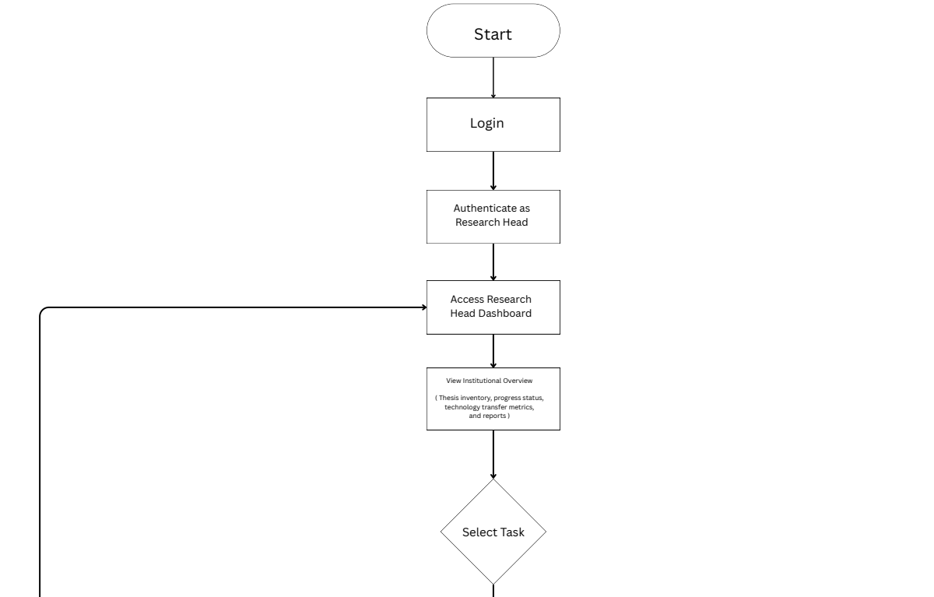

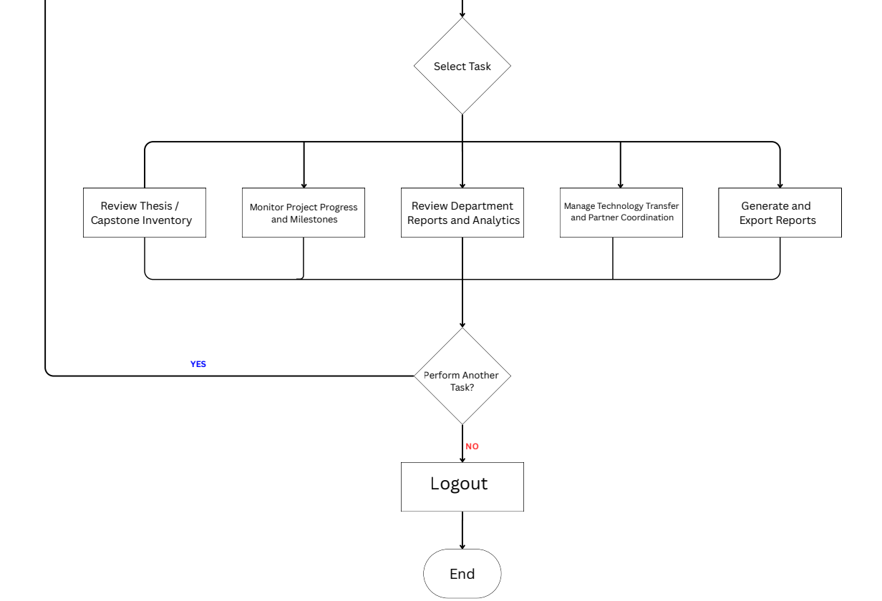

Figure 9 - Research Head Institutional Monitoring and Technology Transfer Workflow

Figure 9 illustrates the workflow of the Research Head within the ThesisTrack system for overseeing institutional research activities and technology transfer operations. The process includes authentication, access to the research management dashboard, monitoring thesis and capstone inventories, reviewing departmental analytics, tracking project progress, coordinating with external partners, and generating institutional reports. The diagram highlights how the Research Head manages centralized oversight and supports research utilization and decision-making within the institution.

Library
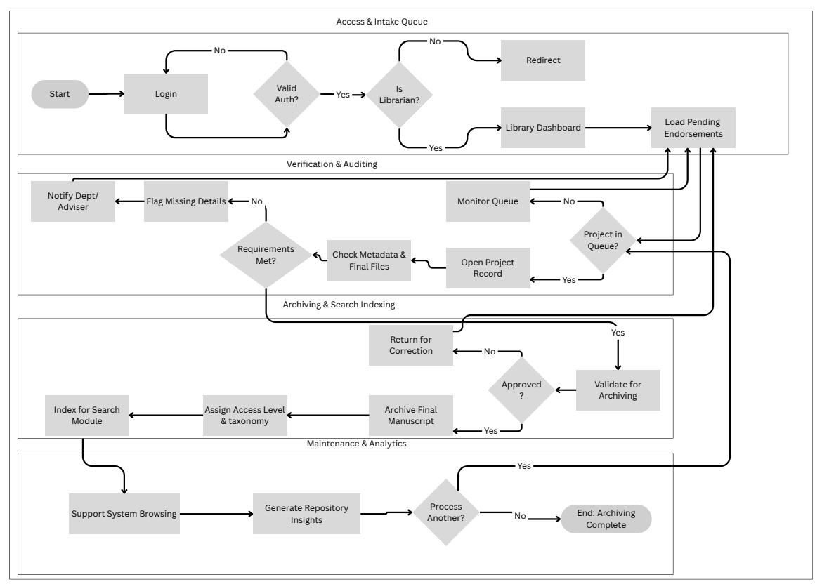
Figure 10 – Library Repository Validation and Archiving Workflow

Figure 10 illustrates the workflow of the Library Personnel within the ThesisTrack system for validating, organizing, and archiving finalized thesis and capstone manuscripts. The process includes authentication, review of pending endorsements, metadata and file verification, repository validation, manuscript archiving, taxonomy assignment, and search indexing. The diagram also highlights how library personnel manage repository maintenance and generate repository insights to support organized institutional record management.

Industry Partner
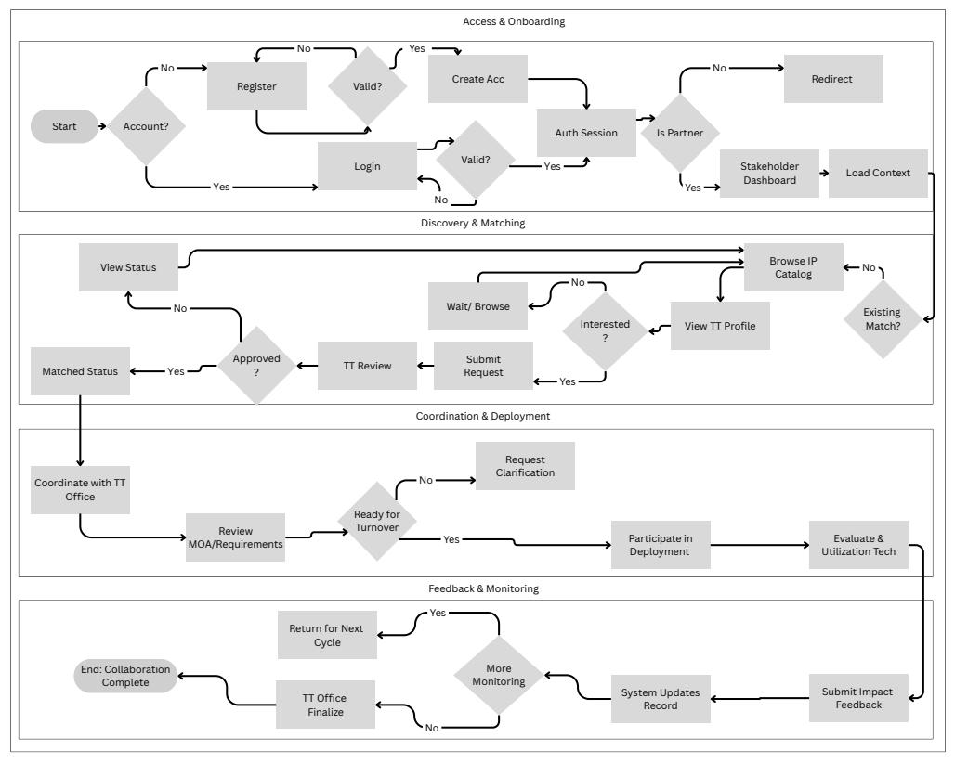
Figure 11 - Industry Partner Collaboration and Technology Transfer Workflow

Figure 11 illustrates the workflow of industry partners within the ThesisTrack system for engaging with academic research and technology transfer activities. The process includes stakeholder registration, project discovery and matching, submission of collaboration requests, coordination with the technology transfer office, deployment participation, and impact feedback monitoring. The diagram highlights how external partners interact with the platform to evaluate, utilize, and support thesis and capstone projects for real-world application and collaboration opportunities.

System Admin
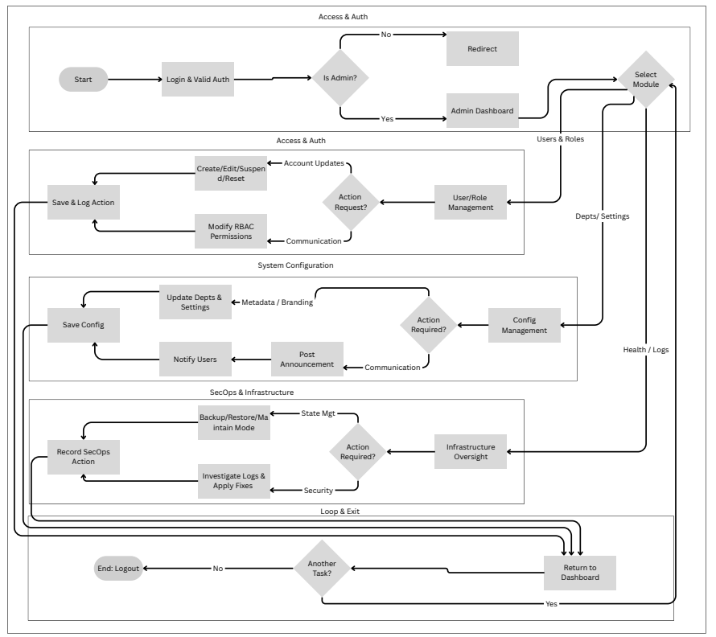
Figure 12 - System Administration and Platform Management Workflow

Figure 12 illustrates the workflow of the System Administrator within the ThesisTrack platform for managing system operations, user access, and technical maintenance. The process includes authentication, user and role management, configuration of departmental settings, announcement handling, security monitoring, backup and maintenance operations, and infrastructure oversight. The diagram highlights how the administrator ensures the stability, security, and continuous operation of the system across all institutional modules and user roles.

Object Modeling
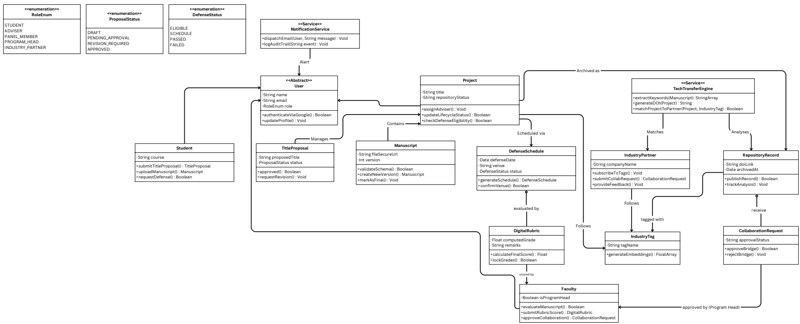Figure 13 – Object Modeling of ThesisTrack

Figure 13 illustrates the object-oriented domain model for managing users, the thesis lifecycle, and industry collaborations. The core system centers on the Project entity, which tracks research progress by linking Student submissions—including TitleProposal and Manuscript versions—to a DefenseSchedule evaluated by Faculty via a DigitalRubric. Once finalized, a TechTransferEngine converts the project into a permanent RepositoryRecord, mapping it to an IndustryPartner through specialized IndustryTag embeddings to facilitate automated CollaborationRequest matching.

Use Case Diagram
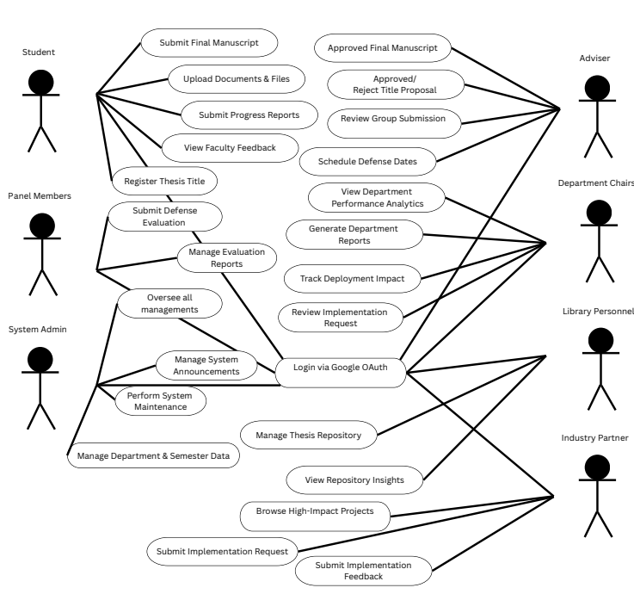

Figure 14 – Functional Interaction of Users and Core Features in the ThesisTrack System

Figure 14 illustrates the interactions between the different stakeholders and the core functionalities of the ThesisTrack system. The diagram identifies the roles of students, advisers, panel members, department chairs, library personnel, industry partners, and system administrators, together with the specific system functions they can access and perform. It highlights how the platform supports thesis management, evaluation, repository administration, progress monitoring, reporting, and technology transfer collaboration within a unified research management environment.

Sequence Diagram
Authentication & Project Registration
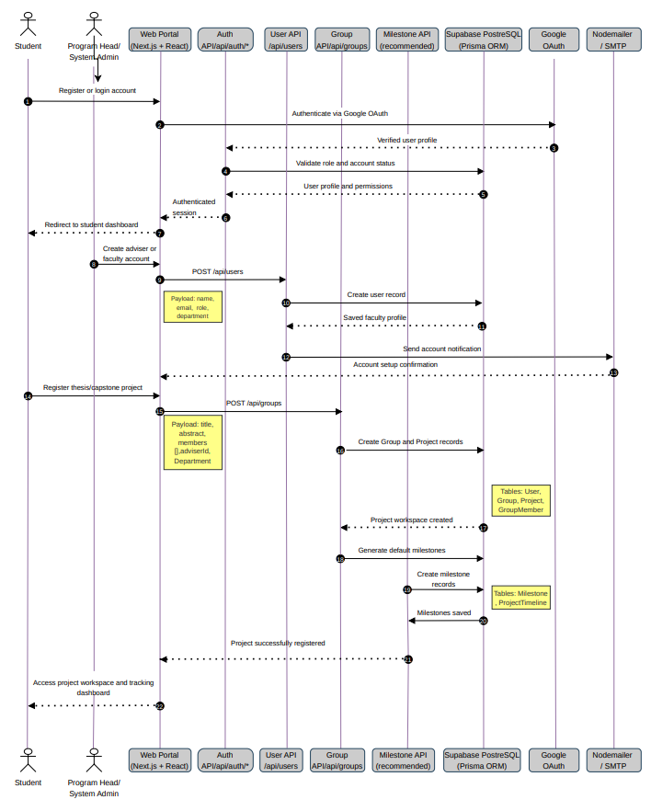
Figure 15 – Authentication and Project Registration Sequence

Figure 15 illustrates the sequence of interactions involved in user authentication, account creation, and thesis or capstone project registration within the ThesisTrack system. The diagram shows how users communicate with the web portal, APIs, database services, and external authentication services to validate accounts, create user profiles, register project groups, and generate milestone records. It highlights the coordinated exchange of data between the frontend, backend, database, and integrated services that support secure access and project initialization.

Manuscript Submission & Faculty Evaluation
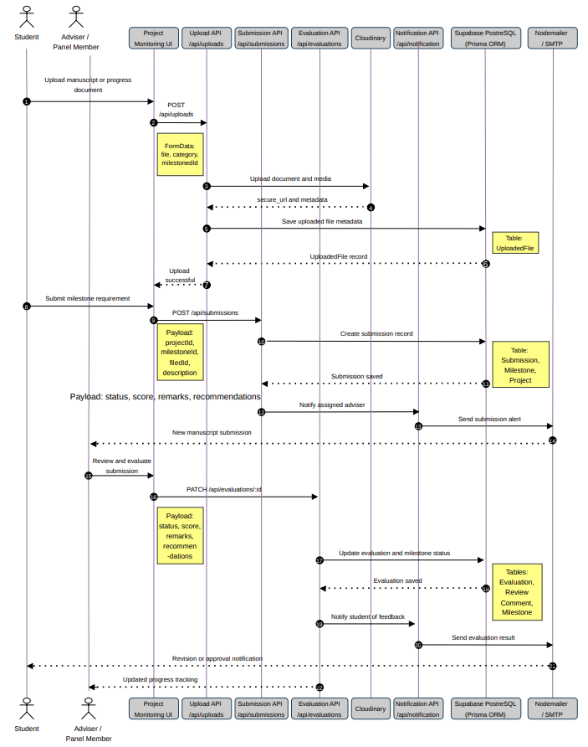
Figure 16 – Manuscript Submission and Faculty Evaluation Sequence Workflow

Figure 16 illustrates the sequence of interactions involved in manuscript submission, milestone processing, and faculty evaluation within the ThesisTrack system. The diagram shows how students upload documents, submit milestone requirements, and receive adviser or panel feedback through coordinated communication between the web interface, APIs, database services, cloud storage, and notification services. It highlights the step-by-step process of file handling, evaluation recording, status updating, and automated notification delivery that supports continuous project monitoring and assessment.

Defense Grading, Repository, and Archiving
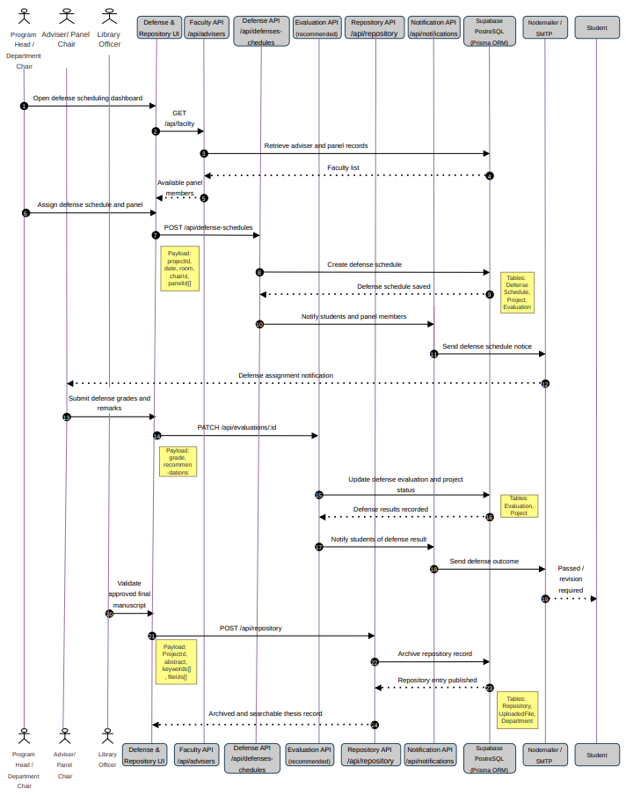

Figure 17 – Defense Evaluation, Repository Validation, and Archiving Sequence Workflow

Figure 17 illustrates the sequence of interactions involved in defense scheduling, grading, manuscript validation, and repository archiving within the ThesisTrack system. The diagram shows how department chairs, advisers, panel members, library personnel, and students interact with the scheduling, evaluation, repository, and notification modules to manage defense activities and final manuscript processing. It highlights the coordinated flow of data between APIs, database services, repository functions, and notification services to support defense evaluation, approval workflows, and institutional archiving of completed research outputs.

Activity Diagram
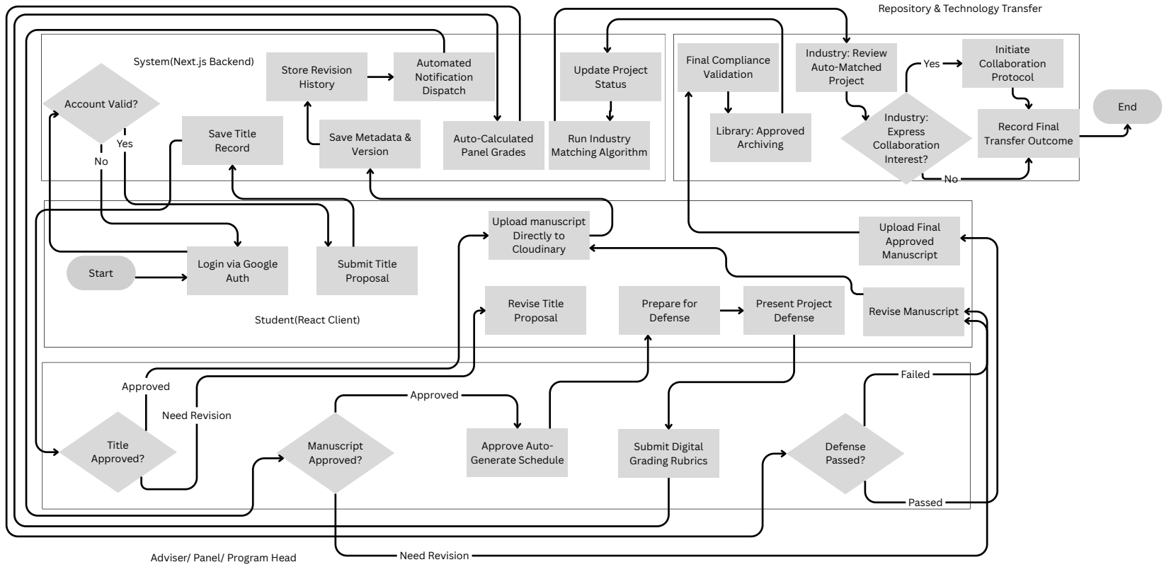
Figure 18 - Integrated Thesis and Capstone Workflow Activity Diagram

Figure 18 illustrates the integrated activity flow of the ThesisTrack system across the entire thesis and capstone lifecycle. The diagram presents the interaction between students, advisers, panel members, program heads, system processes, repository functions, and technology transfer activities from authentication and title proposal submission to manuscript evaluation, defense, repository archiving, and industry collaboration. It also demonstrates how the platform automates notifications, project tracking, grading, revision management, archival validation, and collaboration workflows within a centralized research management environment.

Entity-Relationship-Diagram (ERD)
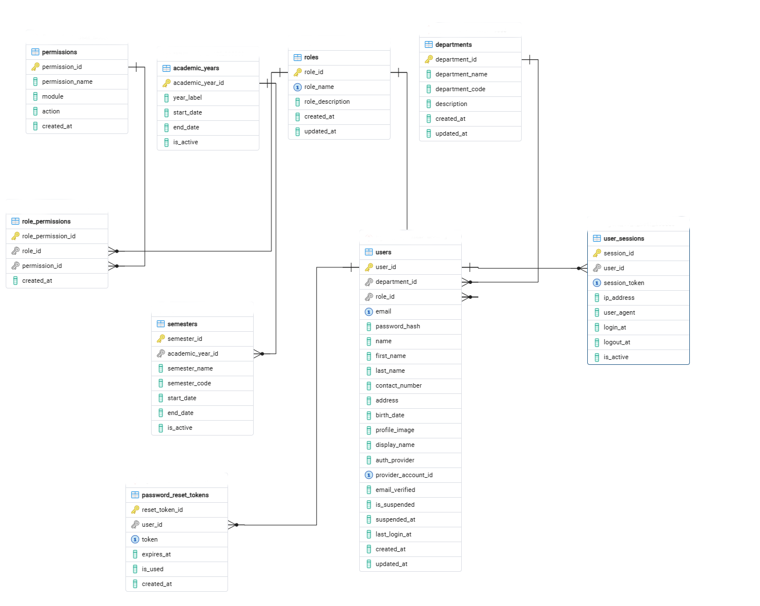
Figure 19.1 – User and Access Management ERD

Users, Roles, Permissions, Role Permissions, Departments, Academic Years, Semesters, User Sessions, Password Reset Tokens

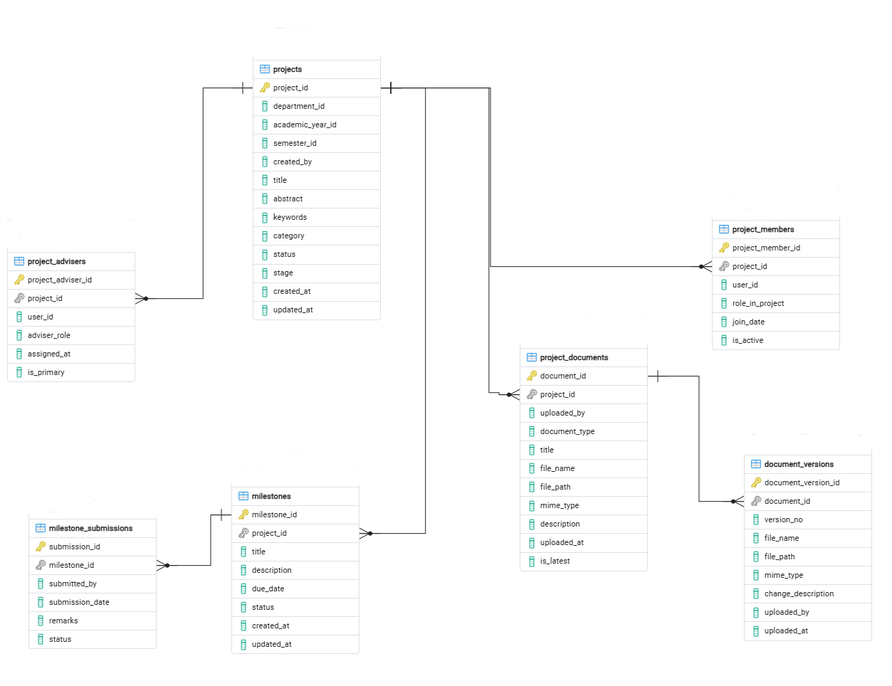

Figure 19.2 – Thesis and Capstone Project Management ERD

Projects, Project Members, Project Advisers, Milestones, Milestone Submissions, Project Documents, Document Versions

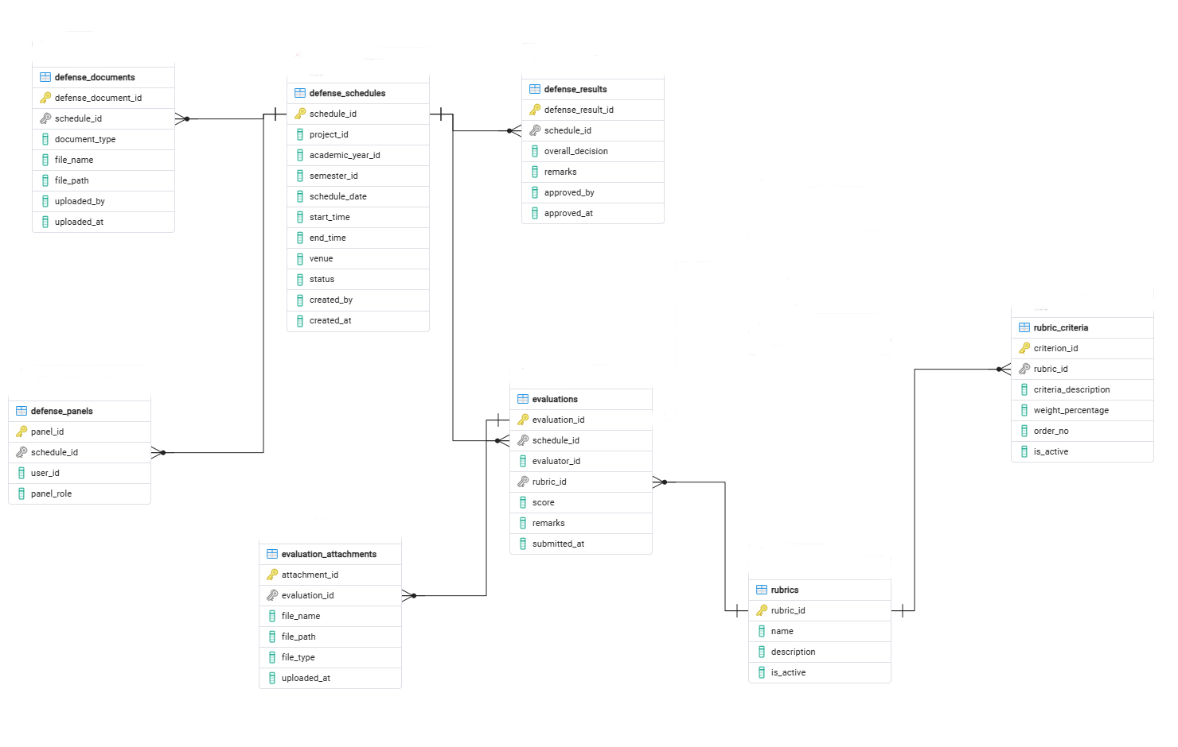

Figure 19.3 – Evaluation and Defense Management ERD

Defense Schedules, Defense Panels, Evaluations, Rubrics, Evaluation Attachments, Defense Results, Defense Documents
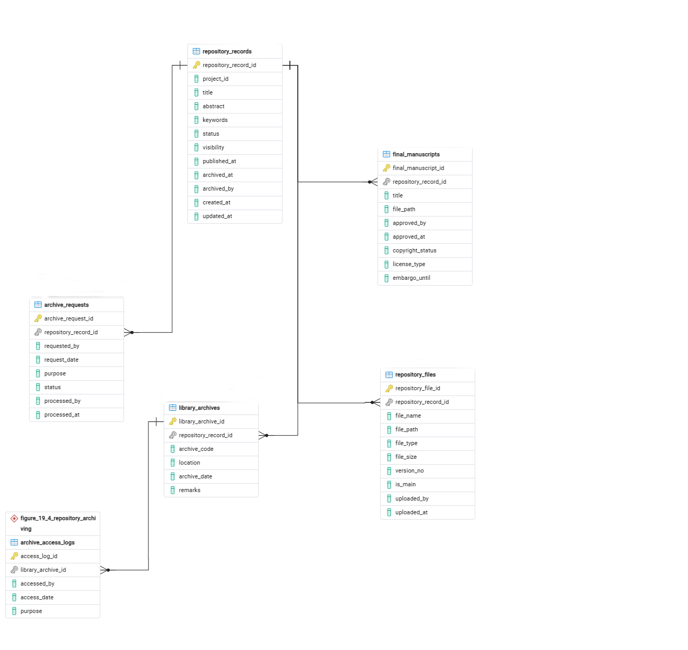
Figure 19.4 – Repository and Archiving Management ERD

Repository Records, Repository Files, Final Manuscripts / Approved Documents, Library Archiving-related tables.

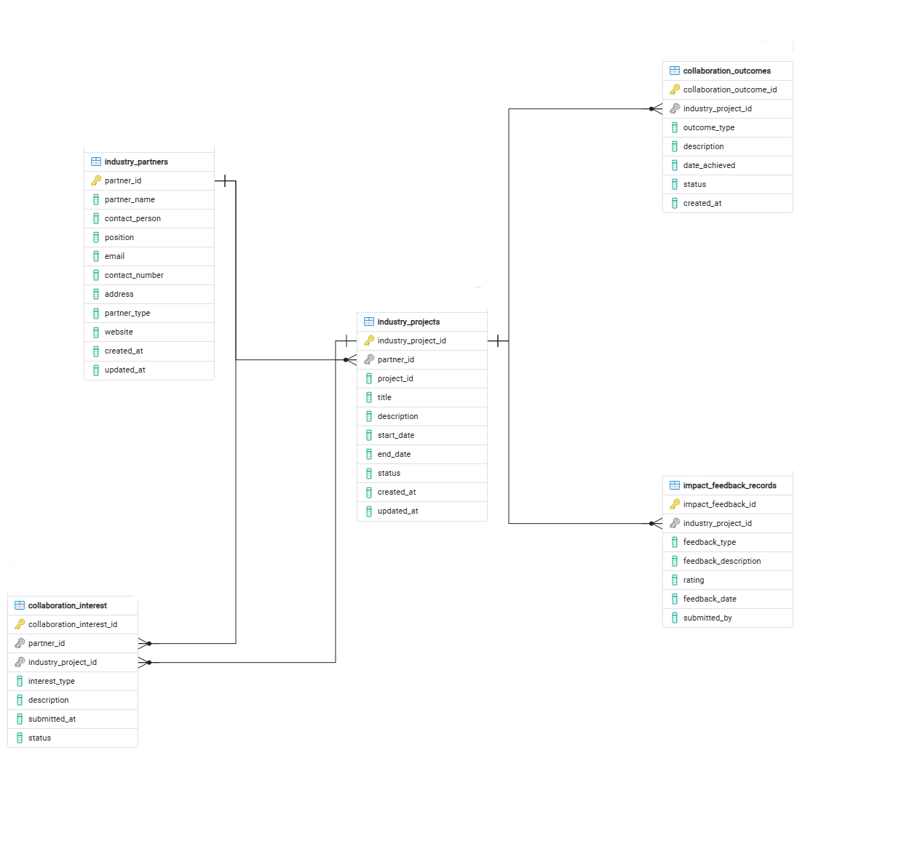
Figure 19.5 – Technology Transfer and Industry Collaboration ERD

Industry Partners, Industry Projects, Collaboration Interest, Collaboration Outcomes, Impact / Feedback Records. Although the ERD is separated into parts for readability, the tables remain logically connected through primary and foreign keys such as user_id, project_id, department_id, repository_record_id, and partner_id.

3.2 Research Environment
The study will be conducted at the University of Science and Technology of Southern Philippines (USTP) – Jasaan Campus, which will serve as the primary site for building and testing the proposed system. The institution is an ideal setting for this research as it offers various academic programs, including BS Information Technology (BS IT), BET Manufacturing Engineering Technology (BET MET), BS Energy System and Management (BS ESM), BS Technology Communication Management (BS TCM), and BS Naval Architecture and Marine Engineering (BS NAME), all of which require students to complete a thesis or capstone project for graduation. Currently, the campus manages these research outputs through manual or only partially digital methods, involving coordination between students, advisers, panelists, department chairs, and the research head.
The research environment encompasses both physical and digital dimensions to ensure the system is evaluated in a realistic institutional context. Physically, the study will be situated within the university’s research office and the IT department. Digitally, the environment will consist of a web-based system supported by a database server, providing a centralized platform for user access across the different stakeholder groups. This environment is suitable for testing because it allows the researchers to observe how the system simplify messy or outdated manual processes and facilitates technology transfer between the university and its external industry or community partners.


Figure 20 – USTP Jasaan Campus Setting

3.3 Unit of Analysis and Respondents of the Study
The unit of analysis for this study will be the system users and system performance. Specifically, this includes the interaction between the stakeholders and the functional modules of the system to determine its effectiveness in an institutional setting. The respondents for this study will include selected students, faculty advisers, panel members, department chairs, and the research head from USTP Jasaan who are directly involved in the thesis and capstone process. These individuals will be chosen because of their firsthand experience in developing, supervising, and managing projects. Their insights and feedback will be vital for testing the proposed system's functionality, ease of use, and overall effectiveness in addressing institutional gaps.

3.3.1 Sampling Technique
The study will employ purposive sampling to select respondents who are directly involved in thesis and capstone project processes. This non-probability sampling method will ensure that only individuals with direct interaction with the research workflow participate in the evaluation. Participants will be selected based on their specific roles to ensure the data gathered is meaningful and aligns with the objectives of the study.
One (1) administrator, specifically the research head, will be selected to represent the overall management of academic and research processes within the institution. In addition, one (1) library personnel will be included to provide insights related to research documentation and repository management. Five (5) department chairs will be selected from the programs of BS Information Technology (BS IT), BET Manufacturing Engineering Technology (BET MET), BS Energy System and Management (BS ESM), BS Technology Communication Management (BS TCM), and BS Naval Architecture and Marine Engineering (BS NAME) to provide data on departmental monitoring practices. Furthermore, ten (10) advisers or panel members consisting of two representatives from each department will be selected to share their experiences in supervising and evaluating student progress.
To address the technology transfer component of the system, one (1) external stakeholder representative, such as a technology transfer officer or industry partner, will be included to ensure the system effectively supports the transition of research to the public domain. And for the student respondents, twenty (20) students will be selected from each of the following programs: BS Technology Communication Management (TCM), BS Information Technology (IT), BET Manufacturing Engineering Technology (MET), BS Energy System and Management (ESM), and BS Naval Architecture and Marine Engineering (NAME). These students will be chosen from the third (3rd) to fourth (4th) year level, as they are actively engaged in thesis or capstone projects. Their participation is important in providing insights into the current challenges, experiences, and needs in managing project development, monitoring progress, and submitting academic requirements.

The selected key informants were:
- One (1) Administrator
- One (1) Library Personnel
- One (1) External Stakeholder Representative
- Five (5) Department Chairs (one from each program) from the following programs:
- Bachelor of Science in Information Technology (IT)
- Bachelor of Science in Manufacturing Engineering Technology (MET)
- Bachelor of Science in Energy System and Management (ESM)
- Bachelor of Science in Technology Communication Management (TCM)
- Bachelor of Science in Naval Architecture and Marine Engineering (NAME)
- Ten (10) Advisers/Panelists (2) from each department
- One Hundred (100) Students (20) from each department (3rd to 4th year level)

The selected respondents will participate in system testing and evaluation using the ISO/IEC 25010 evaluation questionnaire, System Usability Scale (SUS), and User Acceptance Testing (UAT) questionnaire to assess the overall quality, usability, and acceptability of the proposed system.

3.4 Data Gathering Instruments and Procedure
Data will be collected from students, faculty, and administrators at the University of Science and Technology of Southern Philippines, alongside external industry partners. The study will utilize both primary data, such as user evaluation surveys, and secondary data, including existing thesis records and institutional reports. The primary research tool will be a standardized evaluation questionnaire based on the ISO/IEC 25010 framework to gather quantitative data on functional suitability, usability, reliability, and performance efficiency. This instrument will employ a five-point Likert scale ranging from 1 (Strongly Disagree) to 5 (Strongly Agree).
Qualitative data will be obtained through structured interviews specifically with the Research Head and the External Stakeholder Representative. These guided conversations will aim to identify institutional bottlenecks, technology transfer needs, and the specific administrative functionalities required for successful industry-academe collaboration. Additionally, the system itself will serve as a data collection tool, capturing real-time progress reports, milestone tracking, and submission logs.
Ethical standards will be strictly maintained throughout the process. Before participants interact with the research instruments, they will be provided with a formal letter for respondents, an informed consent form, and a data privacy statement. These documents will clearly outline the study's purpose, the voluntary nature of participation, and the guarantee that personal information will remain confidential in compliance with data privacy standards.

The data gathering procedure will be tied directly to the system workflow:

- Secure official authorization from the institution.
- The researchers will develop and deploy the system, followed by the registration of users.
- The users will interact with the various modules, including project uploads, progress monitoring, and partner matching.
- The researchers will distribute the informed consent and data privacy statements, followed by the administration of the system evaluation survey and targeted interviews..

The procedure will conclude with the organization of all collected data for systematic analysis to ensure it meets the study's objectives.

3.5 Statistical Instruments Procedure
The quantitative data collected through the standardized evaluation questionnaires will be analyzed using descriptive statistical methods to ensure a rigorous assessment of the system. The researchers will utilize the Weighted Mean to calculate the overall evaluation scores for each quality category defined by the ISO/IEC 25010 standards, including functional suitability, performance efficiency, usability, reliability, and security. Additionally, the Standard Deviation will be calculated to measure the consistency and distribution of the responses among the various user groups. The study will also employ the System Usability Scale (SUS) to measure the overall usability, ease of use, and user satisfaction of the ThesisTrack system. Furthermore, User Acceptance Testing (UAT) will be conducted to evaluate whether the developed system meets the functional requirements and expectations of its intended users within the institutional environment.
To ensure technical accuracy and statistical rigor, all numerical calculations and data processing will be performed using jamovi software. The resulting mean scores will be interpreted using a five-point scale where a range of 4.50–5.00 is considered Excellent, 3.50–4.49 is Very Good, 2.50–3.49 is Satisfactory, 1.50–2.49 is Fair, and 1.00–1.49 is Poor. For the System Usability Scale (SUS), the collected responses will be computed following the standard SUS scoring procedure and interpreted using established usability benchmarks to determine the overall acceptability and usability level of the system. The results from the User Acceptance Testing (UAT) will also be analyzed to determine whether the system satisfies user expectations in terms of functionality, usability, and workflow integration.
The qualitative information gathered from the structured interviews with the Research Head and the External Stakeholder Representative will be analyzed using Thematic Analysis. The researchers will review the responses to identify recurring patterns and group them into specific themes, such as institutional requirements, administrative bottlenecks, and technology transfer needs. These qualitative insights will be integrated with the quantitative results to provide a comprehensive evaluation that addresses the overall goals of the study.

REFERENCES
Chio, M. E. B., Dal, P. M. M., Garrido, J. L., Baldelovar, A., & Saledaien, J. V. M. (2022). ThesisIT: Web-based university thesis management portal with a defense scheduling system. Science International (Lahore), 34(6), 531–536. https://www.researchgate.net/profile/Jc-Vanny-Mill-Saledaien/publication/374192375_THESISIT_WEB-BASED_UNIVERSITY_THESIS_MANAGEMENT_PORTAL_WITH_A_DEFENSE_SCHEDULING_SYSTEM/links/6517def6321ec5513c225e3d/THESISIT-WEB-BASED-UNIVERSITY-THESIS-MANAGEMENT-PORTAL-WITH-A-DEFENSE-SCHEDULING-SYSTEM.pdf

Perante, W. J. A., Barnaba, E. O., Jr., Cañete, J. R., & Niegas, M. E. (2024). Design and develop a thesis and capstone project manuscript archiving management system for Eastern Visayas State University Ormoc Campus. International Journal of Recent Advances in Multidisciplinary Research, 11(11), 10417–10422. https://www.researchgate.net/profile/Wilferd-Jude-Perante/publication/387225348_DESIGN_AND_DEVELOP_A_THESIS_AND_CAPSTONE_PROJECT_MANUSCRIPT_ARCHIVING_MANAGEMENT_SYSTEM_FOR_EASTERN_VISAYAS_STATE_UNIVERSITY_ORMOC_CAMPUS/links/6764ceb600aa3770e0ad2320/DESIGN-AND-DEVELOP-A-THESIS-AND-CAPSTONE-PROJECT-MANUSCRIPT-ARCHIVING-MANAGEMENT-SYSTEM-FOR-EASTERN-VISAYAS-STATE-UNIVERSITY-ORMOC-CAMPUS.pdf

Reyes, E. R., Almonte, R. G., Montano, M. R. F., & Armario, N. O. (2024). Efficiency Assessment and Design Proposal for Computerized Student Record Management System in Higher Education Institutions. ACM International Conference Proceeding Series, 24, 154–161. https://doi.org/10.1145/3678726.3678765

Goncharenko, I. (2021). CONCEPTUAL MODEL OF THE HACKATHON ECOSYSTEM OF TECHNOLOGY TRANSFER IN AN INSTITUTION OF HIGHER EDUCATION. Management, 33(1), 74–84. https://doi.org/10.30857/2415-3206.2021.1.7

Huang, X. (2025). Technology Transfer in Higher Education. https://phd.lib.uni-corvinus.hu/1416/

Lando, A. L., & Wambua, A. W. (2025). Digital solutions for graduate supervision: A critical analysis of thesis management systems. American Journal of STEM Education, 9, 49–64. https://doi.org/10.32674/sbs52z14

Liu, J., Wang, C., & Xiao, X. (2021). Design and Application of Science and Technology Project Management Information System for Educational Institutes. Mobile Information Systems, 2021(1), 2074495. https://doi.org/10.1155/2021/2074495

Qazdar, A., Hasidi, O., Qassimi, S., & Abdelwahed, E. H. (2023). Newly Proposed Student Performance Indicators Based on Learning Analytics for Continuous Monitoring in Learning Management Systems. International Journal of Online and Biomedical Engineering (iJOE), 19(11), 19-30-19–30. https://doi.org/10.3991/ijoe.v19i11.39471

Regla, A. I., & Ballera, M. A. (2023). An Enhanced Research Productivity Monitoring System for Higher Education Institutions (HEI’s) with Natural Language Processing (NLP). Procedia Computer Science, 230(01), 316–325. https://doi.org/10.1016/j.procs.2023.12.087

Safdar, M. (2021). Creating Institutional Repository in Libraries: The DSpace Experience in Pakistan. Library Philosophy and Practice (e-Journal). https://scholarworks.sjsu.edu/libphilprac/5597

Hailitik, O., Salim, A., Djaha, A., & Amah, M. ’. (2025). The Effectiveness of Academic Monitoring and Evaluation on Length of Study at Nusa Cendana University. International Journal of Environmental, Sustainability, and Social Science, 6(5), 992–1002. https://doi.org/10.38142/IJESSS.V6I5.1482

Palavesm, K., & Joorel, J. P. S. (2022). IRINS: Implementing a Research Information Management System in Indian Higher Education Institutions. Procedia Computer Science, 211(C), 238–245. https://doi.org/10.1016/j.procs.2022.10.197

Batoon, J. A., Leonard, J., Ramos, M., Maverick, J., Pineda, M., Miguel, J., Dizon, L., Carlo, L., Reyes, C., Ahmed, M. B. M., Gordon, R., & Santos, S. D. (2022). THESISQUO: Research Management System with Plagiarism Checker and Prescriptive Analytics. International Journal of Advanced Trends in Computer Science and Engineering, 11(3), 101–107. https://doi.org/10.30534/ijatcse/2022/051132022

Doromal, W. G., & Soberano, K. T. (2023). Capstone Archiving Management System with Citation and Reference Generator. International Journal of Research in Engineering and Science (IJRES) ISSN, 11(9), 128–133. https://www.ijres.org/papers/Volume-11/Issue-9/1109128133.pdf

Simard, M. (2021). Project Management Implementation in a Capstone Design Course. https://doi.org/10.18260/1-2--36313

Sarita, V. B. (2025). Technology Transfer in Higher Education Institutions: A Philippine State Universities and Colleges’ Innovation Ecosystem Scenario. Discourse and Communication for Sustainable Education, 16(1), 137–149. https://doi.org/10.2478/DCSE-2025-0010

APPENDICES




April 14, 2026

ENGR. JOHN MIKEL M. ACMA, M.ENG ME
Head, Research, Innovation and Extension
USTP Jasaan

Good day.

The undersigned are students of the University of Science and Technology of Southern Philippines – Jasaan Campus under the Bachelor of Science in Information Technology (BSIT) program. We respectfully seek your permission to conduct our capstone research entitled “DEVELOPMENT OF A THESIS AND CAPSTONE PROJECT INVENTORY, PROGRESS MONITORING, AND TECHNOLOGY TRANSFER MANAGEMENT SYSTEM FOR HIGHER EDUCATION INSTITUTIONS.” within your organization, in partial fulfillment of the requirements of the program.

The purpose of this study is to design and develop an integrated web-based system that centralizes thesis and capstone project records, improves progress monitoring, and facilitates technology transfer between academic institutions and external stakeholders. Specifically, the study aims to develop a digital inventory repository for organizing research outputs, implement a structured progress monitoring system for tracking project milestones and performance, and create a technology transfer module to support project deployment, partner collaboration, and impact monitoring.

To achieve the objectives of the study, the researchers will need to gather relevant data, including but not limited to:
- Current processes and practices in managing thesis and capstone projects
- Challenges experienced by students, advisers, and administrators in monitoring research progress and managing outputs
- Existing methods of storing, retrieving, and organizing research documents and records
- System requirements and user expectations for features such as inventory management, progress tracking, reporting, and technology transfer

The data will be collected through appropriate data-gathering methods such as surveys, interviews, direct observation, and other necessary research techniques relevant to the study. All data gathered will be used strictly for academic purposes only.

Rest assured that all information obtained during the conduct of the study will be treated with the utmost confidentiality. Participation will be voluntary, and no sensitive information will be disclosed without proper consent.

In this regard, we respectfully request your approval to conduct the study in your organization. Your cooperation will greatly contribute to the successful completion of this research.

Thank you very much for your time and consideration.

Respectfully yours,

ACHAS, PRINCESS MAE CAMILLE N.
BITOS, IVY A.
GRANITEN, KYLE JAPETH C.
JUNTILLA, JAMES ANTHONY Z.
Proponents

Noted by:

JIMVY P. SALISE
Capstone Adviser

Recommending Approval:

JIMVY P. SALISE, MIT DR. RUEL S. SALVADOR, REE
Head, Information Technology Department Acting Campus Director
USTP Jasaan USTP Jasaan

Approved:

ENGR. JOHN MIKEL M. ACMA, M.ENG ME
Head, Research, Innovation and Extension
USTP Jasaan


C.M. Recto Avenue, Lapasan, Cagayan de Oro City 9000 Philippines
Tel Nos. +63 (88) 856 1738; Telefax +63 (88) 856 4696 | http://www.ustp.edu.ph




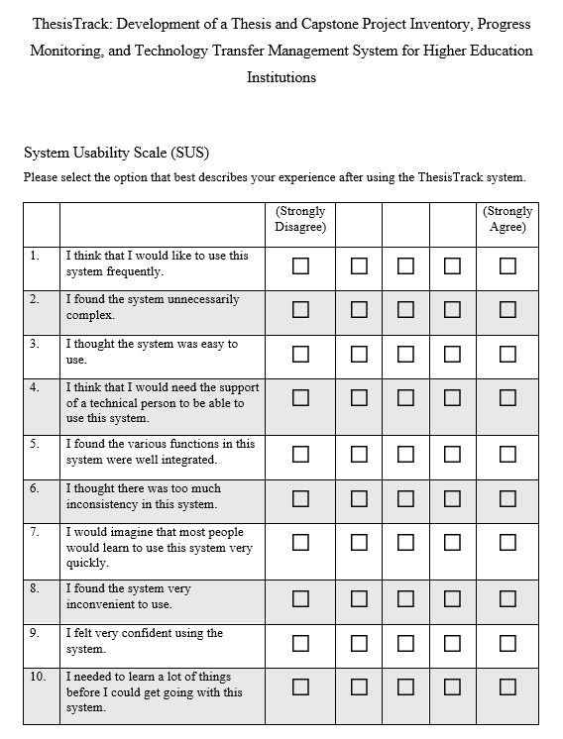
C.M. Recto Avenue, Lapasan, Cagayan de Oro City 9000 Philippines
Tel Nos. +63 (88) 856 1738; Telefax +63 (88) 856 4696 | http://www.ustp.edu.ph




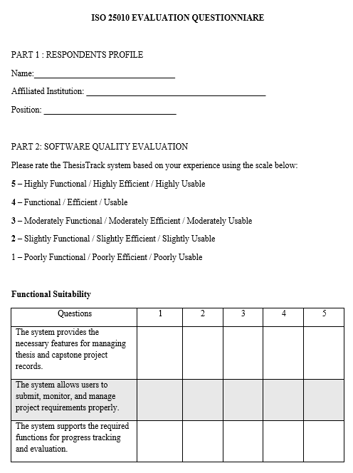

C.M. Recto Avenue, Lapasan, Cagayan de Oro City 9000 Philippines
Tel Nos. +63 (88) 856 1738; Telefax +63 (88) 856 4696 | http://www.ustp.edu.ph





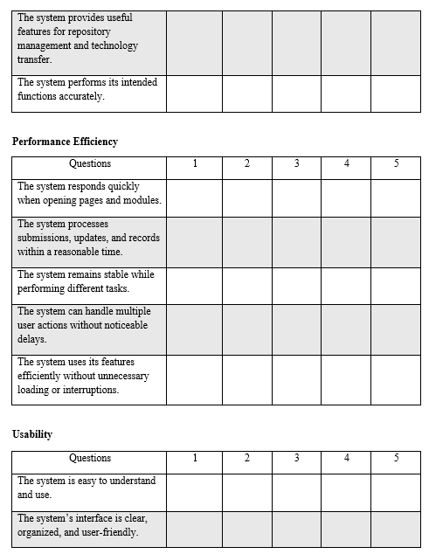
C.M. Recto Avenue, Lapasan, Cagayan de Oro City 9000 Philippines
Tel Nos. +63 (88) 856 1738; Telefax +63 (88) 856 4696 | http://www.ustp.edu.ph



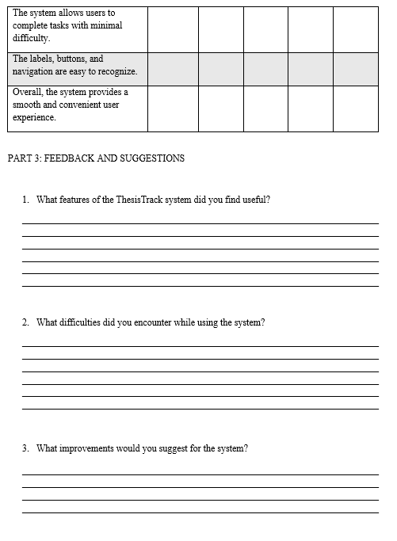

C.M. Recto Avenue, Lapasan, Cagayan de Oro City 9000 Philippines
Tel Nos. +63 (88) 856 1738; Telefax +63 (88) 856 4696 | http://www.ustp.edu.ph



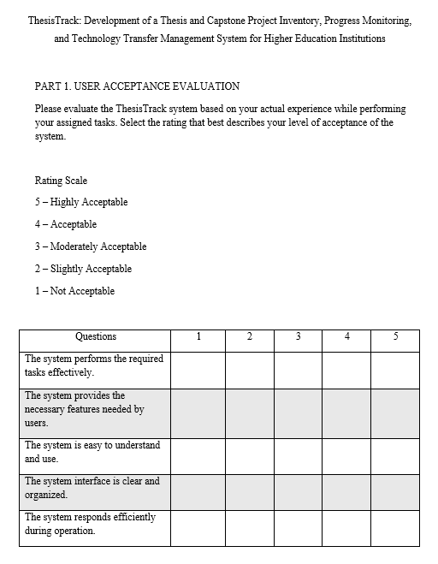

C.M. Recto Avenue, Lapasan, Cagayan de Oro City 9000 Philippines
Tel Nos. +63 (88) 856 1738; Telefax +63 (88) 856 4696 | http://www.ustp.edu.ph



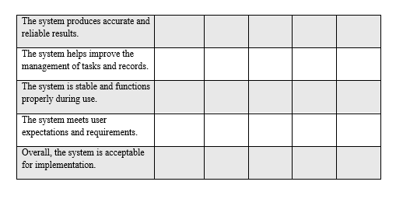


C.M. Recto Avenue, Lapasan, Cagayan de Oro City 9000 Philippines
Tel Nos. +63 (88) 856 1738; Telefax +63 (88) 856 4696 | http://www.ustp.edu.ph

